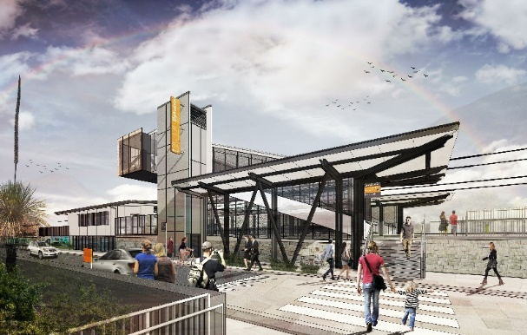

**Dakabin station accessibility upgrade**

**PROJECT UPDATE – MARCH 2020**

**The Dakabin station accessibility upgrade is part of the State Government’s $357 million investment to upgrade stations across the South East Queensland network, making them accessible for all customers.**

**About the project**

The Dakabin station accessibility upgrade will deliver improved station facilities, including raised platforms, new footbridge and lifts and so all customers can travel without barriers.

A new 350-space multi-storey parking facility will replace the existing Thompson Road carpark and will be delivered concurrently with the station accessibility upgrade.

**Project progress**

The following activities have been undertaken recently:

* changes to on-street parking on Thompson Road
* adjustments to overhead line infrastructure
* foundations (screw-piling) in preparation for platform raising
* ongoing station upgrade design
* ongoing community engagement.

**Upcoming works**

In the coming weeks, customers and community can expect to see the following activities:

* **progressive closure of the Thompson Street carpark for construction**
* contractor site establishment
* start of works – water and sewer infrastructure construction.

# 

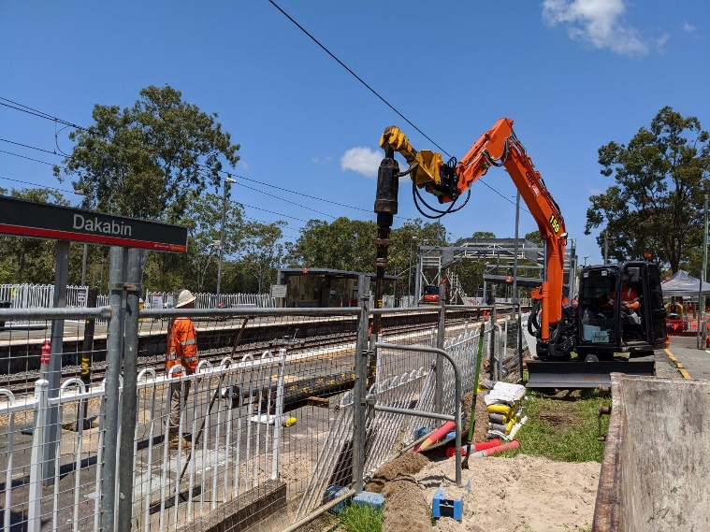

# Construction impacts

**With the anticipated pressures on parking during construction, we strongly encourage customers to consider travelling from other stations with greater parking capacity, where possible.**

# Works will commence this month with the construction of water and sewer infrastructure.

# Construction activities may involve:

* changed parking and traffic conditions for safety
* noise associated with heavy machinery
* temporary changes to access paths throughout the station precinct and surrounding areas
* increased vehicle movements near works
* mobile lighting towers for night works.

# Normal working hours are 6am to 5pm, Monday to Saturday. The local community will be given advance notification of construction activities likely to cause impacts, including after hours work (nights, Sundays and public holidays, if required).

# We thank you for your patience and cooperation as we work to build you a better Dakabin station.

# Contact us

# For more information, to provide feedback or to be added to the project’s opt-in distribution list for email updates:

# Phone: 1800 722 203 (free call)

# Email: stationsupgrade@qr.com.au

# Website: queenslandrail.com.au