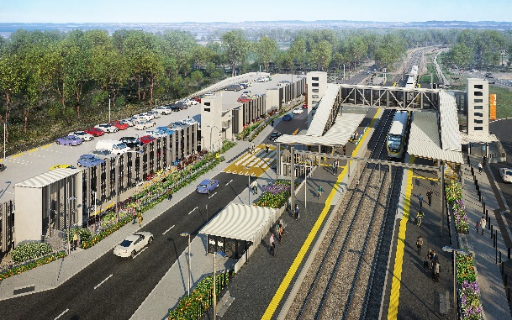

**Dakabin station accessibility upgrade**

**PROJECT UPDATE – MARCH 2021**

**The Dakabin station accessibility upgrade is part of the State Government’s ongoing investment of more than $500 million to upgrade stations across the South East Queensland network, making them accessible for all customers.**

**Project progress**

Works undertaken recently at Dakabin include:

* raised platform paving (pictured)
* early morning concrete pours – carpark
* installation of carpark decks (ongoing)
* Thompson Road realignment works (ongoing)
* installation of steelwork for new station building and waiting shelter (pictured, right)
* commencement of installation of the lift cars
* water main and sewer works, drainage and footpath remediation.

**Upcoming works**

In the next month, the following project activities will be undertaken:

* continuing early morning concrete pours – carpark upper deck
* continuing carpark construction and fit-out
* continuing Thompson Road in-ground services installation
* completion of new station building exterior
* completion of new platform 1 waiting shelter.

# Please take care around the work zones.

# 

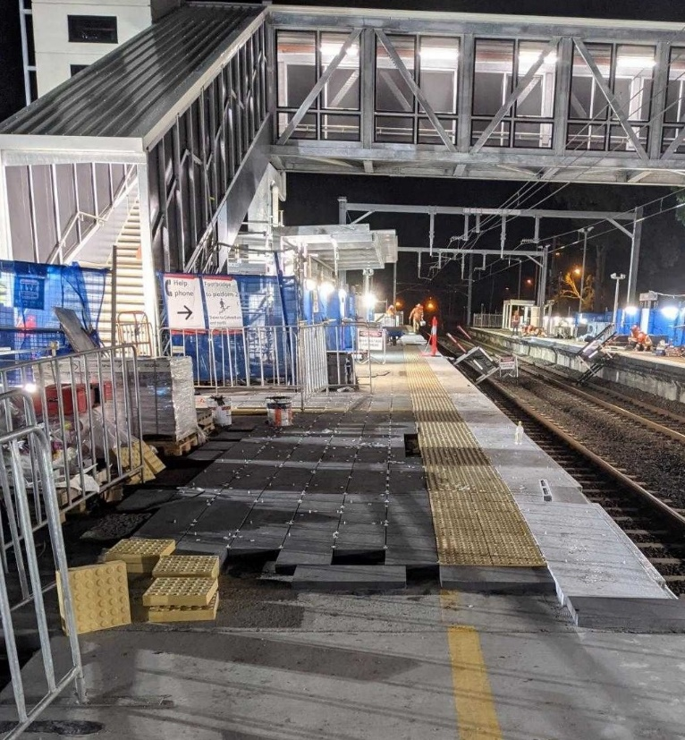

# Construction impacts

# During works, construction activities may involve:

* changed parking and traffic conditions for safety
* noise associated with heavy machinery
* temporary changes to access paths throughout the station precinct and surrounding areas
* increased vehicle movements near works
* mobile lighting towers for night works.

# Thompson Road will be closed to vehicles through the station precinct until approximately mid-2021.

# Customer access to Dakabin station will be maintained, with temporary customer kiss’n’ride zones on Narangba Road (south of the station, opposite Lakeside Road) and at each end of the Thompson Road closure (north, near Alma Road and south, near the temporary station entrance).

# Normal working hours are 6.30am to 6.30pm, Monday to Saturday. The local community will be given advance notification of construction activities likely to cause impacts, including after hours work (nights, Sundays and public holidays, if required).

# Thank you for your patience and cooperation while we build you a better Dakabin station.

# Contact us

# For more information, to provide feedback or to be added to the project’s opt-in distribution list for email updates:

# Phone: 1800 722 203 (free call)

# Email: stationsupgrade@qr.com.au

# Website: queenslandrail.com.au