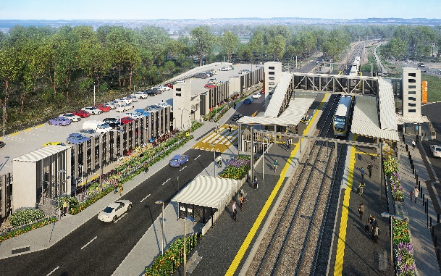

**Dakabin station accessibility upgrade**

**PROJECT UPDATE – MARCH/APRIL 2022**

**The Dakabin station accessibility upgrade is part of the State Government’s ongoing investment of more than $500 million to upgrade stations across the South East Queensland network, making them accessible for all customers.**

**Project progress**

Works recently undertaken at Dakabin include:

* installation of corridor access gates
* installation of retaining walls, footpaths and fencing
* review of completed works and finalisation activities
* ongoing liaison with relevant state authorities for water and wastewater connection, easements and approvals.

**Upcoming works**

In the coming weeks, customers and the community can expect to see the following activities:

* reopening of Thompson Road to vehicles (subject to approval)
* opening upgraded kiss’n’ride facilities and the western carpark
* certification of fire systems and opening of multi-storey carpark.

**Update on station facilities**

Works are nearing completion and the main project team presence has demobilised from site.

The new station building and multi-storey carpark are currently undergoing water connections along with testing and certification of the fire management systems by the relevant authorities. This is an important step in opening the station facilities to the public.

We are also working with Council to obtain approval to reopen Thompson Road to through traffic.

We appreciate that our customers are keen to use the new facilities and we will bring you an update on our progress soon.

# Construction impacts

# During works, construction activities may involve:

* changed parking and traffic conditions for safety
* noise associated with heavy machinery
* temporary changes to access paths throughout the station precinct and surrounding areas
* increased vehicle movements near works
* mobile lighting towers for night works.

# Normal working hours are 6.30am to 6.30pm, Monday to Saturday.

# The local community will be given advance notification of construction activities likely to cause impacts, including after hours work (nights, Sundays and public holidays, if required).

# Please take care around the works zones. Thank you for your patience while we build you a better Dakabin station.

# Contact us

# For more information, to provide feedback or to be added to the project’s opt-in distribution list for email updates:

# Phone: 1800 722 203 (free call)

# Email: stationsupgrade@qr.com.au

# Website: queenslandrail.com.au