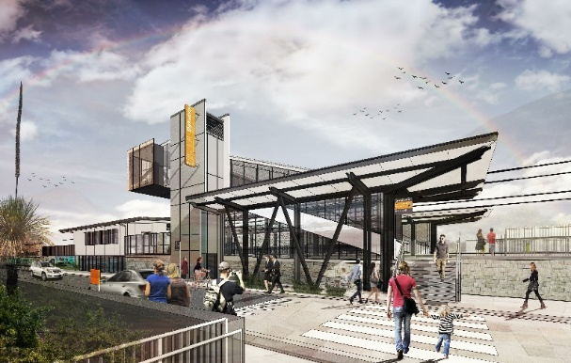

**Dakabin station accessibility upgrade**

**PROJECT UPDATE – MAY 2020**

**The Dakabin station accessibility upgrade is part of the State Government’s $357 million investment to upgrade stations across the South East Queensland network, making them accessible for all customers.**

**Project progress**

Works have now commenced on site, with the following activities undertaken recently:

* contractor site establishment
* changes to on-street parking on Thompson Road
* adjustments to overhead line infrastructure
* removal of existing waiting shelters
* commencement of water and sewer infrastructure construction.

**Upcoming works**

In the coming weeks, customers and community can expect to see the following activities:

* **progressive closure of the Thompson Street carpark for construction**
* demolition and earthworks
* ongoing foundations (screw-piling) and platform raising
* tree removal (adjacent to Thompson Road) to enable construction of the multi-storey carpark
* water and sewer infrastructure construction
* temporary works.

**Past student artwork available**

In 2011/12, Queensland Rail collaborated with artist Scott Breton and the students of Dakabin State High School to decorate the station through our positive pARTnerships initiative.

Prior to the recent demolition of the station’s original waiting shelters, the project team carefully removed these artworks. If you were involved with this art project and would like your own piece of local history, please contact us to have your masterpiece returned.

# 

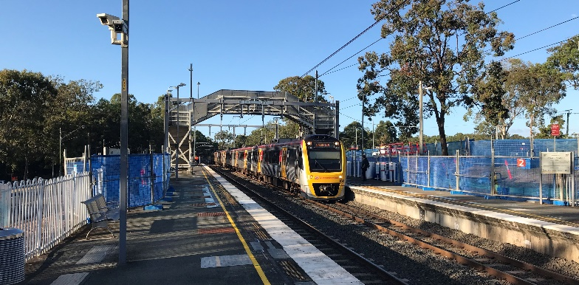

# Construction impacts

**With the anticipated pressures on parking during construction, we strongly encourage customers to consider travelling from other stations with greater parking capacity, where possible.**

# During works, construction activities may involve:

* changed parking and traffic conditions for safety
* noise associated with heavy machinery
* temporary changes to access paths throughout the station precinct and surrounding areas
* increased vehicle movements near works
* mobile lighting towers for night works.

# For safety, the pedestrian path between the station carpark and Dakabin State High School’s rear gate is now closed for the duration of works.

# Normal working hours have been reviewed and will be 6.30am to 6.30pm, Monday to Saturday. The local community will be given advance notification of construction activities likely to cause impacts, including after hours work (nights, Sundays and public holidays, if required).

# We thank you for your patience and cooperation as we build you a better Dakabin station.

# Contact us

# For more information, to provide feedback or to be added to the project’s opt-in distribution list for email updates:

# Phone: 1800 722 203 (free call)

# Email: stationsupgrade@qr.com.au

# Website: queenslandrail.com.au