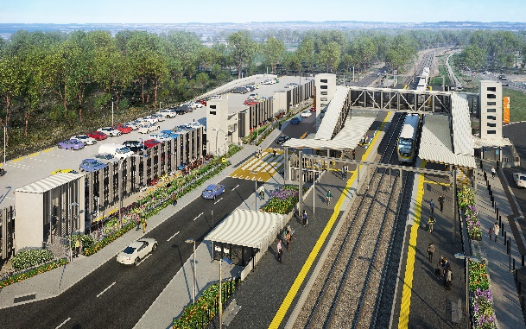

**Dakabin station accessibility upgrade**

**PROJECT UPDATE – NOVEMBER 2021**

**The Dakabin station accessibility upgrade is part of the State Government’s ongoing investment of more than $500 million to upgrade stations across the South East Queensland network, making them accessible for all customers.**

**Project progress**

Works recently undertaken at Dakabin include:

* removal of temporary pedestrian access ramps and opening of new station entrance (Thompson Road)
* reinstatement of Thompson Road (ongoing)
* road pavement works to Narangba Road slip lane and kiss’n’ride (western carpark)
* testing and pre-opening inspection of lifts
* installation of *go* card and ticketing equipment on platform 1
* installation of platform furniture
* final carpark line-marking
* landscaping.

**Upcoming works**

In the coming weeks, customers and the community can expect to see the following activities:

* ticket office fit-out
* installation of *go* card and ticketing equipment on platform 2
* electrical works – light pole installation.

# Please take care around the work zones.

# Construction impacts

# During works, construction activities may involve:

* changed parking and traffic conditions for safety
* noise associated with heavy machinery
* temporary changes to access paths throughout the station precinct and surrounding areas
* increased vehicle movements near works
* mobile lighting towers for night works.

# Normal working hours are 6.30am to 6.30pm, Monday to Saturday. The local community will be given advance notification of construction activities likely to cause impacts, including after hours work (nights, Sundays and public holidays, if required).

**Thompson Road closure**

Thompson Road (through the station precinct), pictured above, will be closed until Tuesday 30 November 2021.

# Temporary customer kiss’n’ride zones are provided on Narangba Road (south of the station, opposite Lakeside Road) and at each end of the Thompson Road closure.

# Pedestrian access along Thompson Road via the new station entrance is now open.

# We appreciate your patience and continued cooperation and look forward to delivering the new Dakabin station and multi-storey carpark.

# Contact us

# For more information, to provide feedback or to be added to the project’s opt-in distribution list for email updates:

# Phone: 1800 722 203 (free call)

# Email: stationsupgrade@qr.com.au

# Website: queenslandrail.com.au