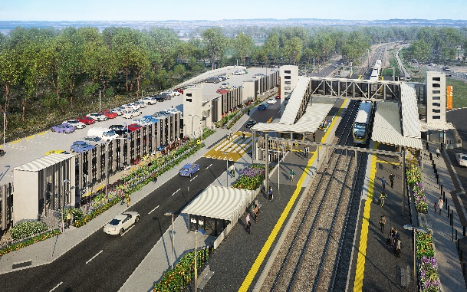

**Dakabin station accessibility upgrade**

**PROJECT UPDATE – OCTOBER / NOVEMBER 2020**

**The Dakabin station accessibility upgrade is part of the State Government’s investment to upgrade stations across the South East Queensland network, making them accessible for all customers.**

**Project progress**

Works undertaken recently at Dakabin include:

* temporary closure of Thompson Road through the station precinct for safety
* completion of carpark excavations, bulk earthworks and piling
* retaining wall structures along new Thompson Road alignment
* foundations/footings for stairs, lift shafts and new station building
* installation of stormwater detention tanks
* off-site construction of lift shaft and stair components.

**Upcoming works**

In the coming weeks, the following project activities will be undertaken:

* continuing carpark works, including concrete slabs, structural columns and fire pump room
* commencement of station lift shaft and footbridge stairs installation
* structural steel work – station building and platforms
* Thompson Road realignment works
* water main and sewer works, drainage and footpath remediation.

The station’s platforms will be closed for uninterrupted works from 1.45am Saturday 5 until 4am Monday 7 December. Rail services will not stop at Dakabin during this time. Half-hourly shuttle bus services will take customers to Petrie to connect with all services (allow additional 30 minutes’ travel time).

# 

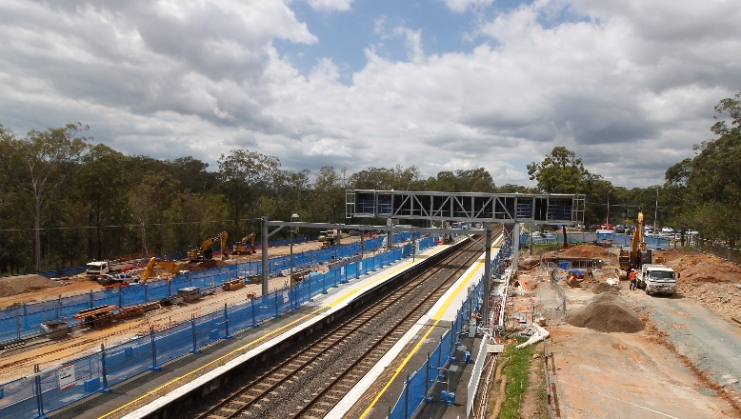

# Construction impacts

# During works, construction activities may involve:

* changed parking and traffic conditions for safety
* noise associated with heavy machinery
* temporary changes to access paths throughout the station precinct and surrounding areas
* increased vehicle movements near works
* mobile lighting towers for night works.

# Thompson Road will be closed to vehicles through the station precinct until approximately mid-2021.

# Customer access to Dakabin station will be maintained, with temporary customer kiss’n’ride zones on Narangba Road (south of the station, opposite Lakeside Road) and at each end of the Thompson Road closure (north, near Alma Road and south, near the temporary station entrance).

# Normal working hours are 6.30am to 6.30pm, Monday to Saturday. The local community will be given advance notification of construction activities likely to cause impacts, including after hours work (nights, Sundays and public holidays, if required).

# Please take care around the work zones.

# Thank you for your patience and cooperation while we build you a better Dakabin station.

# Contact us

# For more information, to provide feedback or to be added to the project’s opt-in distribution list for email updates:

# Phone: 1800 722 203 (free call)

# Email: stationsupgrade@qr.com.au

# Website: queenslandrail.com.au