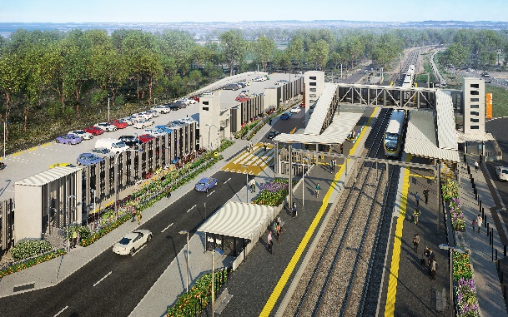

**Dakabin station accessibility upgrade**

**PROJECT UPDATE – SEPTEMBER 2020**

**The Dakabin station accessibility upgrade is part of the State Government’s $357 million investment to upgrade stations across the South East Queensland network, making them accessible for all customers.**

**Project progress**

Works undertaken recently at Dakabin include:

* foundations – lift shafts and bridge footings
* assembly and installation of new footbridge
* earthworks – Thompson Road carpark
* water and sewer infrastructure construction.

**Upcoming works**

In the coming weeks, the following project activities will be undertaken:

* off-site construction of lift shaft components (ongoing)
* water main and sewer works (ongoing)
* continuing carpark works
* closure of Thompson Road through the station precinct for safety.

**Thompson Road closure from 28 September**

To enable the safe construction of the Dakabin station accessibility upgrade and multi-storey carpark, Queensland Rail will **temporarily close Thompson Road** to vehicles through the station precinct for up to nine months, **from Monday 28 September 2020 until mid-2021**.

Traffic management will be in place to direct road users and pedestrians around the closure. Vehicle turnaround facilities will be provided on Thompson Road at each end of the closure.

The alternative route for through traffic will be **via Ann Street, Marsden Road and Alma Road**.

Safe north-south pedestrian access will be maintained. The lit path through Bob Brock Park will provide a pedestrian connection with Marsden Road.

Customer access to Dakabin station will be maintained during the road closure and the station will continue to operate throughout construction.

Temporary customer set down (kiss’n’ride) zones will operate on Narangba Road (south of the station, opposite Lakeside Road) and at each end of the Thompson Road closure (north, near Alma Road and south, near the temporary station entrance).

# 



# Construction impacts

# During works, construction activities may involve:

* changed parking and traffic conditions for safety
* noise associated with heavy machinery
* temporary changes to access paths throughout the station precinct and surrounding areas
* increased vehicle movements near works
* mobile lighting towers for night works.

# Normal working hours are 6.30am to 6.30pm, Monday to Saturday. The local community will be given advance notification of construction activities likely to cause impacts, including after hours work (nights, Sundays and public holidays, if required).

# Thank you for your patience and cooperation while we build you a better Dakabin station.

# Contact us

# For more information, to provide feedback or to be added to the project’s opt-in distribution list for email updates:

# Phone: 1800 722 203 (free call)

# Email: stationsupgrade@qr.com.au

# Website: queenslandrail.com.au