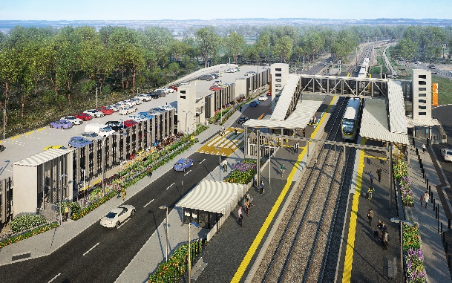

**Dakabin station accessibility upgrade**

**PROJECT UPDATE – SEPTEMBER 2021**

**The Dakabin station accessibility upgrade is part of the State Government’s ongoing investment of more than $500 million to upgrade stations across the South East Queensland network, making them accessible for all customers.**

**Project progress**

Works undertaken at Dakabin in August include:

* adjustments to pedestrian paths throughout the station precinct to enable works
* station building fit-out (ongoing)
* ongoing lift installations – station and carpark
* Thompson Road and footpath subgrade installation
* construction of new bicycle enclosure (ongoing)
* embankment works – near platform 1
* drainage installation – Narangba Road slip road.

**Upcoming works**

In the next month, customers and the community can expect to see the following activities:

* platform works and lighting
* footpaths, kerbs and channels – Thompson Road
* testing and commissioning of new fire protection pump system for carpark
* completion of fire services enclosure
* commissioning of permanent electrical power supply
* testing and commissioning of carpark lighting.

# Please take care around the work zones.

**Thompson Road closure**

To facilitate the completion of the multi-storey carpark, the Thompson Road closure (through the station precinct) has been extended to late October 2021.

# We appreciate your patience and continued cooperation and look forward to delivering the new Dakabin station and multi-storey carpark.

# 

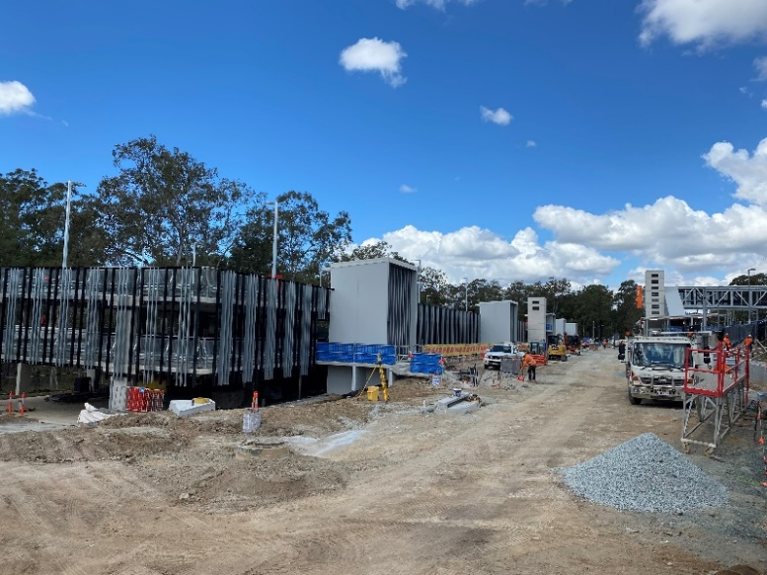

# Construction impacts

# During works, construction activities may involve:

* changed parking and traffic conditions for safety
* noise associated with heavy machinery
* temporary changes to access paths throughout the station precinct and surrounding areas
* increased vehicle movements near works
* mobile lighting towers for night works.

# Customer access to Dakabin station will be maintained, with temporary customer kiss’n’ride zones on Narangba Road (south of the station, opposite Lakeside Road) and at each end of the Thompson Road closure (north, near Alma Road and south, near the temporary station entrance).

# Normal working hours are 6.30am to 6.30pm, Monday to Saturday. The local community will be given advance notification of construction activities likely to cause impacts, including after hours work (nights, Sundays and public holidays, if required).

# Contact us

# For more information, to provide feedback or to be added to the project’s opt-in distribution list for email updates:

# Phone: 1800 722 203 (free call)

# Email: stationsupgrade@qr.com.au

# Website: queenslandrail.com.au