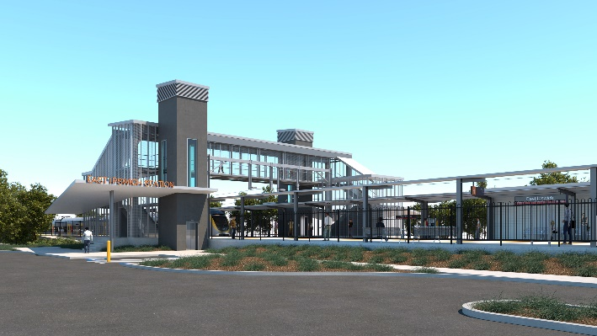

**East Ipswich station accessibility upgrade**

**PROJECT UPDATE – AUGUST 2019**

**Queensland Rail’s East Ipswich station accessibility upgrade is part of the program to upgrade stations across the South East Queensland network, making them accessible for all customers.**

# The project

# ​Queensland Rail is upgrading East Ipswich station to improve accessibility and make it easier and safer for customers to use.

# The station upgrade is designed to achieve independent accessibility, meaning that all train platforms can be accessed independently via paths, ramps or lifts, without the need to use stairs.

# Through the design process we discovered it was not feasible to upgrade the existing station in its current location due to ground stabilisation, drainage and the condition of the 60-year-old station building and platforms.

# A new station will be constructed adjacent to the existing precinct, sharing approximately 40 metres of existing platform and extending 120 metres (towards Brisbane).

# Features of the upgrade include:

* a new pedestrian footbridge with lift access
* fully-raised platforms
* a new, modern station building
* new station entrances on Merton Street and Coronation Street
* additional shade/shelter and a new covered area over the core zone
* improved accessible parking
* new bicycle enclosure
* upgraded hearing augmentation loop and tactile surfaces
* upgraded security cameras and station lighting
* new wayfinding and platform signage.

# Project status

# In preparation for the accessibility upgrade, Queensland Rail will undertake preliminary works during a scheduled track closure on Saturday 3 and Sunday 4 August 2019. Some piling and concreting works commenced in the rail corridor in late July.

# Additional early works have been planned around scheduled track closures in October 2019 and January 2020. Some associated works, including night works, may be required before and after these track closures. Nearby residents will be provided advance notification of these works.

# Contact us

# For more information or to provide feedback, please contact:

# Phone: 1800 722 203 (free call)

# Email: stationsupgrade@qr.com.au

# Website: queenslandrail.com.au

**PROJECT TIMELINE**

**May 2019**

Concept Design released

**Mid to late 2019**

Reference Design

**July/August 2019**

Early Works

**Mid 2020**

Main Construction commences

**January 2020**

Early Works

**October 2019**

Early Works

**Early 2020**

Contractor award and

Detailed Design

