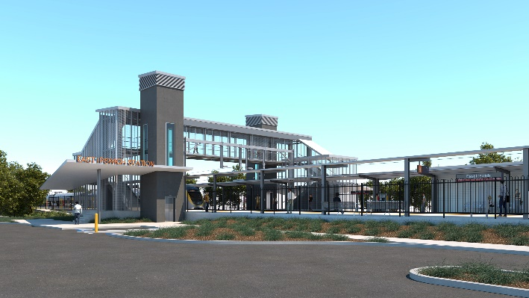

**East Ipswich station accessibility upgrade**

**PROJECT UPDATE – DECEMBER 2020**

**The East Ipswich station accessibility upgrade is part of the State Government’s ongoing investment of more than $500 million to upgrade stations across the South East Queensland network, making them accessible for all customers.**

**Project progress**

The following works have been undertaken recently at East Ipswich:

* excavation and foundation screw piling (drilling) – existing platform and rail corridor
* ongoing stormwater and sewerage works – Coronation Street (southern) side of the station
* retaining walls
* structural steel work.

**Upcoming works**

In the coming weeks customers and the community can expect to see the following activities:

* ongoing stormwater and sewerage works
* platform concreting
* footbridge and stair component manufacture (off-site).

# Please take care around the work zones.

Project works on site will shut down for the Christmas and New Year period for two weeks from Friday 18 December 2020.

We wish you all a safe and happy festive season.

# 

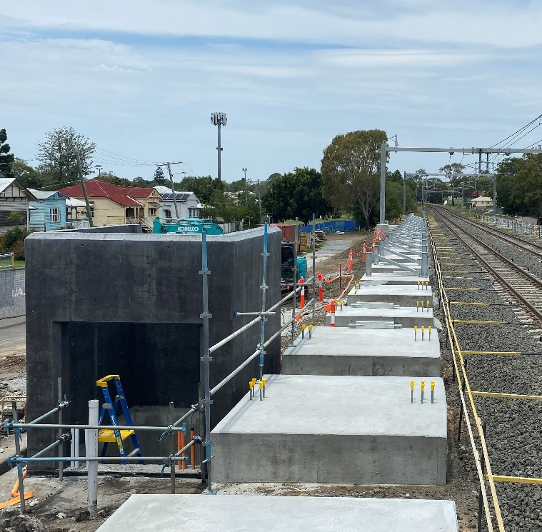

# Construction impacts

# During works, construction activities may involve:

* changed parking and traffic conditions for safety
* noise associated with heavy machinery
* temporary changes to access paths throughout the station precinct and surrounding areas
* increased vehicle movements near works
* mobile lighting towers for night works.

# Normal working hours are 6.30am to 6.30pm, Monday to Saturday.

# The local community will be given advance notification of construction activities likely to cause impacts, including after hours work (nights, Sundays and public holidays, if required).

# Thank you for your patience and cooperation as we build you a better East Ipswich station.

# Contact us

# For more information, to provide feedback or to be added to the project’s opt-in distribution list for email updates:

# Phone: 1800 722 203 (free call)

# Email: stationsupgrade@qr.com.au

# Website: queenslandrail.com.au