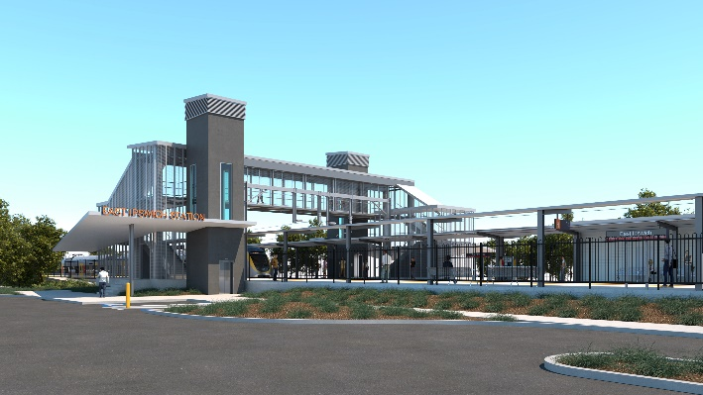

**East Ipswich station accessibility upgrade**

**PROJECT UPDATE – DECEMBER 2021**

**The East Ipswich station accessibility upgrade is part of the State Government’s ongoing investment of more than $500 million to upgrade stations across the South East Queensland network, making them accessible for all customers.**

**Project progress**

The following works were recently undertaken at East Ipswich:

* station building and platform works
* continuing ticket office fit-out
* installation of new bike facilities
* station entrances and footpath works
* landscaping.

**Upcoming works**

In the coming weeks, customers and the community can expect to see the following activities:

* removal of safety fencing around some work zones
* commissioning of lifts
* commencement of new station operations
* temporary closure of the Bennett Street carpark and station access (see below)
* demolition works (ongoing).

**Ongoing activities – old station demolition and path construction**

Demolition of the old station building and platforms, will continue into 2022.

The Bennett Street carpark will temporarily close to customers from Monday 20 December 2021 until approximately mid-2022 to enable demolition works and the construction of a pedestrian path connecting Bennett Street with the new station.

Please follow directional signage and take care around the work zones.

# Construction impacts

# During works, construction activities may involve:

* changed parking and traffic conditions for safety
* noise associated with heavy machinery
* temporary changes to access paths throughout the station precinct and surrounding areas
* increased vehicle movements near works
* mobile lighting towers for night works.

# Normal working hours are 6.30am to 6.30pm, Monday to Saturday.

# The local community will be given advance notification of construction activities likely to cause impacts, including after hours work (nights, Sundays and public holidays, if required).

**Season’s greetings**

We appreciate your patience and continued cooperation throughout the construction of your new East Ipswich station.

Project works on site will shut down for the Christmas and New Year period from Monday 20 December 2021, returning Tuesday 4 January 2022.

# We wish you all a safe and happy festive season.

# Contact us

# For more information, to provide feedback or to be added to the project’s opt-in distribution list for email updates:

# Phone: 1800 722 203 (free call)

# Email: stationsupgrade@qr.com.au

# Website: queenslandrail.com.au