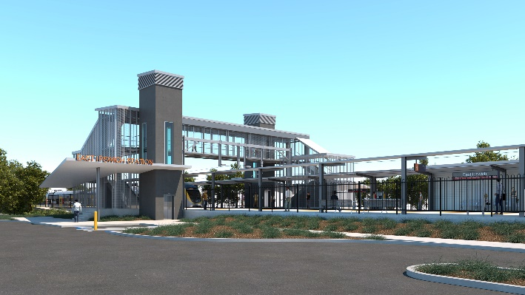

**East Ipswich station accessibility upgrade**

**PROJECT UPDATE – FEBRUARY 2022**

**The East Ipswich station accessibility upgrade is part of the State Government’s ongoing investment of more than $500 million to upgrade stations across the South East Queensland network, making them accessible for all customers.**

**Project progress**

The following works were recently undertaken at East Ipswich:

* opening of the new station
* closing of the old station precinct for safety
* commencement of demolition activities – old platforms and station building (pictured, right)
* review of the lighting system (post-installation) – ongoing assessment.

**Upcoming works**

In the coming weeks, customers and the community can expect to see the following activities:

* ongoing demolition activities – old platforms and station building
* commencement of construction of new accessible path between Bennett Street carpark and the new station precinct.

New path construction and demolition of the old station building and platforms will continue until mid-2022.

The Bennett Street carpark and station entrance will be closed for the duration of demolition works and path construction activities.

Please take care around the work zones.

# Construction impacts

# During works, construction activities may involve:

* changed parking and traffic conditions for safety
* noise associated with heavy machinery
* temporary changes to access paths throughout the station precinct and surrounding areas
* increased vehicle movements near works
* mobile lighting towers for night works.

# Normal working hours are 6.30am to 6.30pm, Monday to Saturday.

# The local community will be given advance notification of construction activities likely to cause impacts, including after hours work (nights, Sundays and public holidays, if required).

# Thank you for your patience and cooperation as we build you a better East Ipswich station.

# Contact us

# For more information, to provide feedback or to be added to the project’s opt-in distribution list for email updates:

# Phone: 1800 722 203 (free call)

# Email: stationsupgrade@qr.com.au

# Website: queenslandrail.com.au