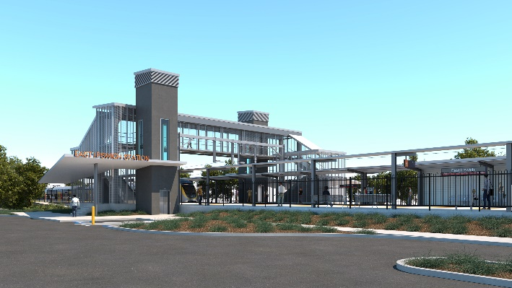

**East Ipswich station accessibility upgrade**

**PROJECT UPDATE – JANUARY 2021**

**The East Ipswich station accessibility upgrade is part of the State Government’s investment of more than $500 million to upgrade stations across the South East Queensland network, making them accessible for all customers.**

**Project progress**

The following works have been undertaken recently at East Ipswich:

* excavation and foundation screw piling
* stormwater and sewerage works – Coronation Street (southern) side of the station
* construction of retaining walls
* installation of structural steel.

**Upcoming works**

In the coming weeks customers and the community can expect to see the following activities:

* platform concrete works
* bridge foundation construction
* in-ground services (water, sewerage and electrical).

# Please take care around the work zones.

# 

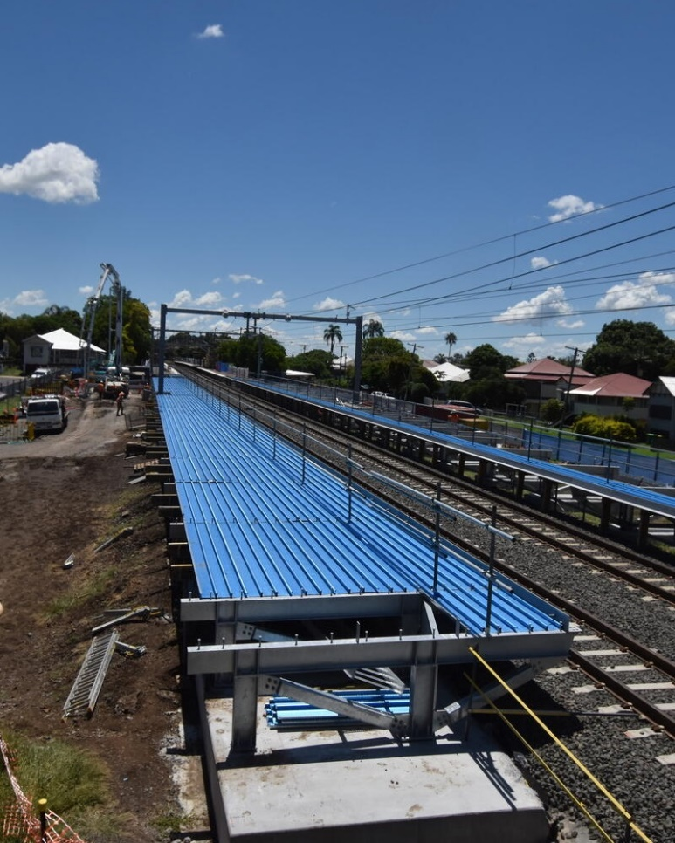

# Construction impacts

# During works, construction activities may involve:

* changed parking and traffic conditions for safety
* noise associated with heavy machinery
* temporary changes to access paths throughout the station precinct and surrounding areas
* increased vehicle movements near works
* mobile lighting towers for night works.

# Normal working hours are 6.30am to 6.30pm, Monday to Saturday.

# The local community will be given advance notification of construction activities likely to cause impacts, including after hours work (nights, Sundays and public holidays, if required).

# Thank you for your patience and cooperation as we build you a better East Ipswich station.

# Contact us

# For more information, to provide feedback or to be added to the project’s opt-in distribution list for email updates:

# Phone: 1800 722 203 (free call)

# Email: stationsupgrade@qr.com.au

# Website: queenslandrail.com.au