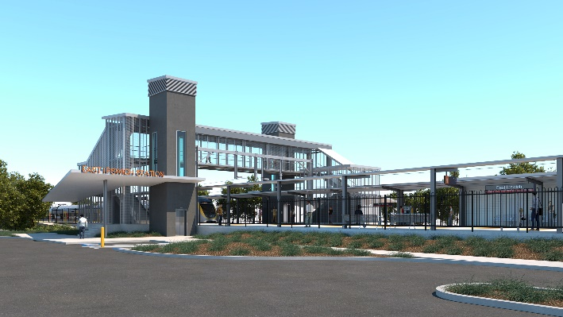

**East Ipswich station accessibility upgrade**

**PROJECT UPDATE – JUNE 2021**

**The East Ipswich station accessibility upgrade is part of the State Government’s ongoing investment of more than $500 million to upgrade stations across the South East Queensland network, making them accessible for all customers.**

**Project progress**

The following works have been undertaken recently at East Ipswich:

* stormwater and sewage works
* ongoing platform works
* mural design competition and selection.

**Upcoming works**

In the coming weeks customers and the community can expect to see the following activities:

* raising sections of existing platforms
* restoration and reinstallation of heritage shelter (in new location)
* installation of stairs to new footbridge
* lift installation (ongoing).

**Temporary weekend station closure (12, 13 June)**

The station’s platforms will be closed for uninterrupted works from 11.30pm Friday 11 until 4am Monday 14 June.

Rail services will not stop at East Ipswich on Saturday 12 and Sunday 13 June. Half-hourly shuttle (maxi taxi) services will operate from stops in Gibbon Street (near Coronation Street) and Merton Street to take customers to and from Ipswich station to connect with all services (allow an additional 30 minutes’ travel time).

**Mural design winner announced**

Congratulations to Glen Smith whose photograph was selected for the design of the station’s new mural.

Inspired by the historic city of Ipswich, Glen captured his photo of Brisbane Street while on an early morning walk. The mural will become a feature of the new station building in the coming months.

# Construction impacts

# During works, construction activities may involve:

* changed parking and traffic conditions for safety
* noise associated with heavy machinery
* temporary changes to access paths throughout the station precinct and surrounding areas
* increased vehicle movements near works
* mobile lighting towers for night works.

# Normal working hours are 6.30am to 6.30pm, Monday to Saturday.

# The local community will be given advance notification of construction activities likely to cause impacts, including after hours work (nights, Sundays and public holidays, if required).

# Thank you for your patience and cooperation as we build you a better East Ipswich station.

# Contact us

# For more information, to provide feedback or to be added to the project’s opt-in distribution list for email updates:

# Phone: 1800 722 203 (free call)

# Email: stationsupgrade@qr.com.au

# Website: queenslandrail.com.au