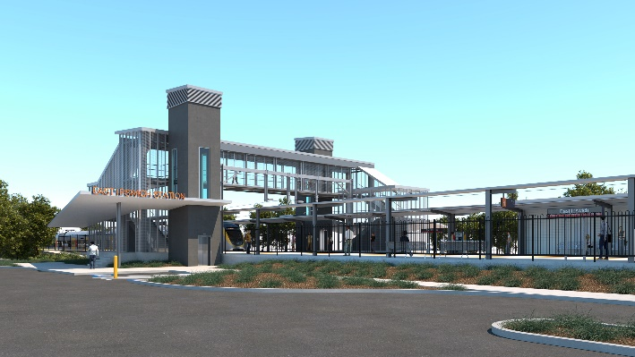

**East Ipswich station accessibility upgrade**

**PROJECT UPDATE – MAY 2021**

**The East Ipswich station accessibility upgrade is part of the State Government’s ongoing investment of more than $500 million to upgrade stations across the South East Queensland network, making them accessible for all customers.**

**Project progress**

The following works have been undertaken recently at East Ipswich:

* new platform concrete pours
* stormwater and sewage works
* removal of heritage shelter
* assembly and installation of new footbridge (early May, pictured below).

**Upcoming works**

In the coming weeks customers and the community can expect to see the following activities:

* relocation of heritage shelter (in new location)
* raising sections of existing platforms
* installation of stairs to new footbridge
* lift installation (ongoing)
* mural design competition and selection.

The station’s platforms will be closed for uninterrupted works from 11.30pm Friday 11 until 4am Monday 14 June. Rail services will not stop at East Ipswich during this time. Half-hourly shuttle bus services will take customers to Ipswich station to connect with all services (allow an additional 30 minutes’ travel time).

# Construction impacts

# During works, construction activities may involve:

* changed parking and traffic conditions for safety
* noise associated with heavy machinery
* temporary changes to access paths throughout the station precinct and surrounding areas
* increased vehicle movements near works
* mobile lighting towers for night works.

# Normal working hours are 6.30am to 6.30pm, Monday to Saturday.

# The local community will be given advance notification of construction activities likely to cause impacts, including after hours work (nights, Sundays and public holidays, if required).

# Thank you for your patience and cooperation as we build you a better East Ipswich station.

# Contact us

# For more information, to provide feedback or to be added to the project’s opt-in distribution list for email updates:

# Phone: 1800 722 203 (free call)

# Email: stationsupgrade@qr.com.au

# Website: queenslandrail.com.au