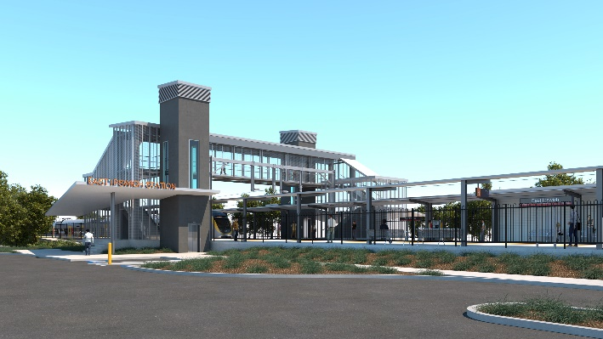

**East Ipswich station accessibility upgrade**

**PROJECT UPDATE – OCTOBER 2021**

**The East Ipswich station accessibility upgrade is part of the State Government’s ongoing investment of more than $500 million to upgrade stations across the South East Queensland network, making them accessible for all customers.**

**Project progress**

The following works were recently undertaken at East Ipswich:

* platform works (ongoing)
* station building works
* ongoing lift installation
* ongoing stormwater and sewerage works
* entrance ramp works – Coronation Street
* concrete pour – retaining wall footings.

**Upcoming works**

In the coming months, customers and the community can expect to see the following activities:

* platform works
* ticket office fit-out
* removal of old timber footbridge and opening of new footbridge (stair-only), late October
* construction of station entrances, footpaths and kerbing
* lift installation and commissioning
* commissioning of new station facilities
* decommissioning of old station facilities and commencement of demolition.

Construction of the new station is expected to be completed in late 2021. Supporting works, including the demolition of the old station building and platforms, will continue into 2022.

# 

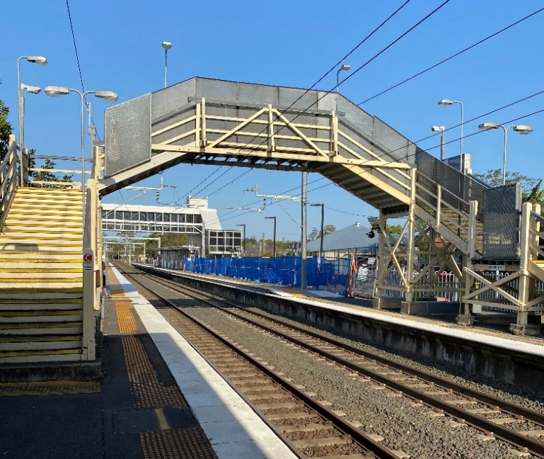

# Construction impacts

# During works, construction activities may involve:

* changed parking and traffic conditions for safety
* noise associated with heavy machinery
* temporary changes to access paths throughout the station precinct and surrounding areas
* increased vehicle movements near works
* mobile lighting towers for night works.

# Normal working hours are 6.30am to 6.30pm, Monday to Saturday.

# The local community will be given advance notification of construction activities likely to cause impacts, including after hours work (nights, Sundays and public holidays, if required).

# Thank you for your patience and cooperation as we build you a better East Ipswich station.

# Contact us

# For more information, to provide feedback or to be added to the project’s opt-in distribution list for email updates:

# Phone: 1800 722 203 (free call)

# Email: stationsupgrade@qr.com.au

# Website: queenslandrail.com.au