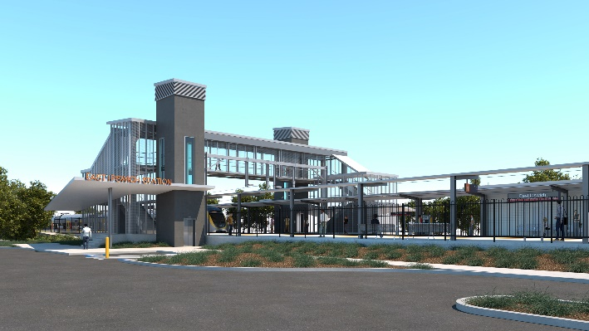

**East Ipswich station accessibility upgrade**

**PROJECT UPDATE – OCTOBER / NOVEMBER 2020**

**The East Ipswich station accessibility upgrade is part of the State Government’s investment to upgrade stations across the South East Queensland network, making them accessible for all customers.**

**Project progress**

The following works have been undertaken recently at East Ipswich:

* commencement of main construction
* track and civil works – track, sleeper and ballast replacement and earthworks
* excavation and foundation screw piling (drilling) – existing platform and rail corridor
* commencement of stormwater works – Coronation Street (southern) side of the station
* relocation of gas main under rail corridor (gas provider APA).

**Upcoming works**

In the coming weeks customers and the community can expect to see the following activities:

* ongoing stormwater and sewerage works – Coronation Street (southern) side of the station
* continuing excavation and foundation screw piling (drilling)
* retaining walls
* structural steel work.

# Please take care around the work zones.

The station’s platforms will be closed for uninterrupted works from 11.30pm Friday 27 until 4am Monday 30 November. Rail services will not stop at East Ipswich during this time. Half-hourly shuttle bus services will take customers to Ipswich station to connect with all services (allow an additional 30 minutes’ travel time).

# 

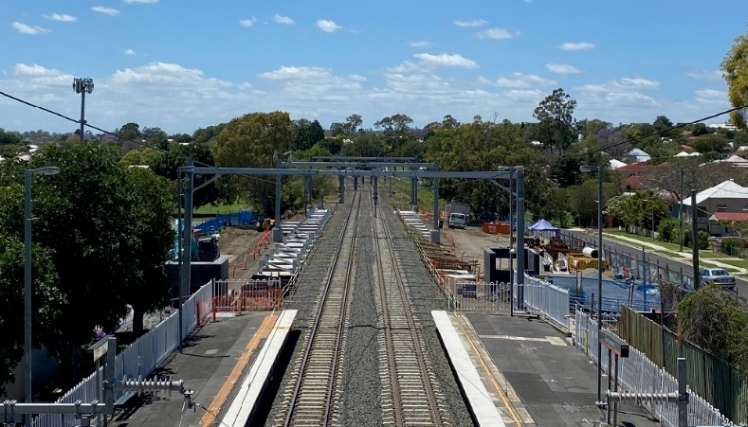

# Construction impacts

# During works, construction activities may involve:

* changed parking and traffic conditions for safety
* noise associated with heavy machinery
* temporary changes to access paths throughout the station precinct and surrounding areas
* increased vehicle movements near works
* mobile lighting towers for night works.

# Normal working hours are 6.30am to 6.30pm, Monday to Saturday.

# The local community will be given advance notification of construction activities likely to cause impacts, including after hours work (nights, Sundays and public holidays, if required).

# Thank you for your patience and cooperation as we build you a better East Ipswich station.

# Contact us

# For more information, to provide feedback or to be added to the project’s opt-in distribution list for email updates:

# Phone: 1800 722 203 (free call)

# Email: stationsupgrade@qr.com.au

# Website: queenslandrail.com.au