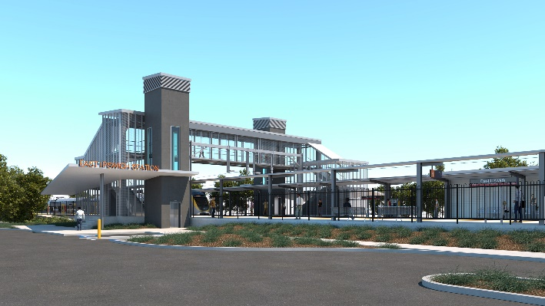

**East Ipswich station accessibility upgrade**

**PROJECT UPDATE – SEPTEMBER 2020**

**The East Ipswich station accessibility upgrade is part of the State Government’s $357 million investment to upgrade stations across the South East Queensland network, making them accessible for all customers.**

**Project progress**

The following works have been undertaken recently at East Ipswich:

* commencement of detailed design
* contractor mobilisation, site establishment and fencing of work zones
* ongoing community and stakeholder engagement.

**Upcoming works**

In the coming weeks customers and the community can expect to see the following activities:

* commencement of main construction
* track and civil works (during weekend track closure, 5 and 6 September)
* tree removal (in the rail corridor, Merton Street) to enable construction works
* excavation and foundation screw piling (drilling)
* commencement of stormwater works – Coronation Street (southern) side of the station.

# 

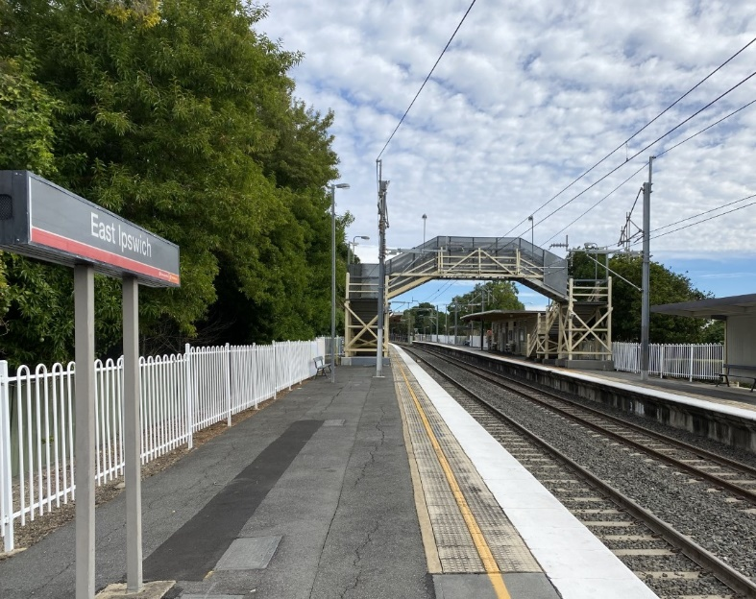

# Construction impacts

The station upgrade has been designed with consideration given to local trees and preserving the 'look and feel' of the station surrounds.

# During works, construction activities may involve:

* changed parking and traffic conditions for safety
* noise associated with heavy machinery
* temporary changes to access paths throughout the station precinct and surrounding areas
* increased vehicle movements near works
* mobile lighting towers for night works.

# Normal working hours are 6.30am to 6.30pm, Monday to Saturday.

# The local community will be given advance notification of construction activities likely to cause impacts, including after hours work (nights, Sundays and public holidays, if required).

# Thank you for your patience and cooperation as we build you a better East Ipswich station.

# Contact us

# For more information, to provide feedback or to be added to the project’s opt-in distribution list for email updates:

# Phone: 1800 722 203 (free call)

# Email: stationsupgrade@qr.com.au

# Website: queenslandrail.com.au

# Novel Coronavirus (COVID-19)

# Queensland Rail is committed to keeping essential rail services operating for Queenslanders during this challenging time and to do this, network maintenance and critical works must continue. To support workforce safety, Queensland Rail has implemented a number of additional control measures related to COVID-19 management. We will continue to take the necessary precautions to ensure the ongoing health and wellbeing of our team and the communities in which we operate.