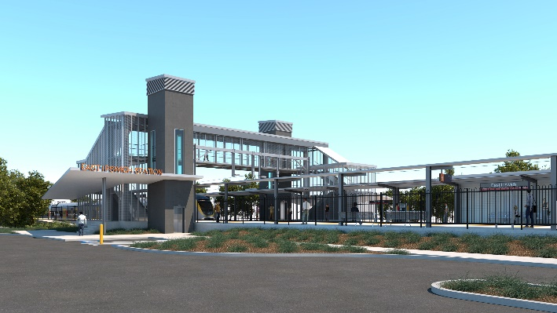

**East Ipswich station accessibility upgrade**

**PROJECT UPDATE – SEPTEMBER 2021**

**The East Ipswich station accessibility upgrade is part of the State Government’s ongoing investment of more than $500 million to upgrade stations across the South East Queensland network, making them accessible for all customers.**

**Project progress**

The following works were undertaken at East Ipswich in August:

* demobilisation and removal of site offices (Merton Street)
* establishment of new temporary site offices (Ipswich Vigoro Association property)
* entrance ramp works – Coronation Street
* concrete pour – retaining wall footings
* surveying activities and civil works – platform 2
* station building works
* electrical works – platform 1
* roofing and painting – relocated heritage shelter
* lift installation (ongoing)
* stormwater and sewerage works (ongoing).

**Upcoming works**

In the coming months, customers and the community can expect to see the following activities:

* platform works
* station building works
* ongoing lift installation
* ongoing stormwater and sewerage works
* removal of old timber footbridge
* commissioning of new station facilities
* preparations for demolition of old station building and platforms.

Construction of the new station is expected to be completed in late 2021. Supporting works, including the demolition of the old station building and platforms, will continue into 2022.

# 

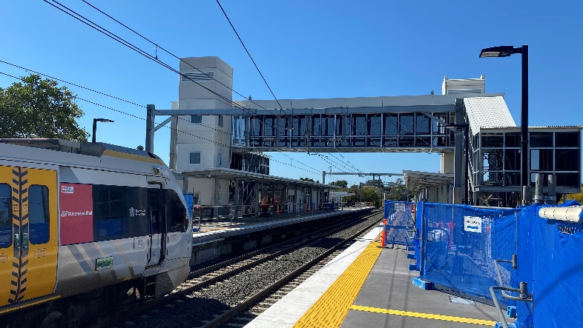

# Construction impacts

# During works, construction activities may involve:

* changed parking and traffic conditions for safety
* noise associated with heavy machinery
* temporary changes to access paths throughout the station precinct and surrounding areas
* increased vehicle movements near works
* mobile lighting towers for night works.

# Normal working hours are 6.30am to 6.30pm, Monday to Saturday.

# The local community will be given advance notification of construction activities likely to cause impacts, including after hours work (nights, Sundays and public holidays, if required).

# Thank you for your patience and cooperation as we build you a better East Ipswich station.

# Contact us

# For more information, to provide feedback or to be added to the project’s opt-in distribution list for email updates:

# Phone: 1800 722 203 (free call)

# Email: stationsupgrade@qr.com.au

# Website: queenslandrail.com.au