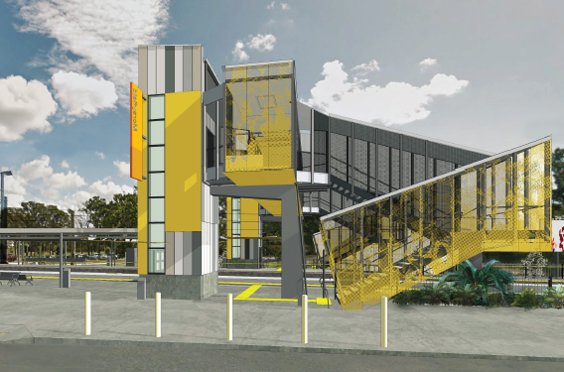
Morayfield station accessibility upgrade

PROJECT UPDATE – AUGUST 2018

The Morayfield station accessibility upgrade is part of Queensland Rail’s $300 million program to upgrade stations across the South East Queensland network, making them accessible for all customers.

Early works to date
Since site establishment in late 2017, early works for the accessibility upgrade have included laying foundations and relocating the overhead electrification equipment. This will enable the raising of the platform around the assisted boarding point.
Upcoming works
In the coming months, customers and the community can expect to see the following activities:
- set up of project compound and safety fencing
- installation of temporary ticket office and toilet, including excavation, plumbing and electrical works (August/September)
- construction of driveway connection between the western carpark and Caboolture Sports Club (expected to commence late August)
- commissioning of temporary ticket office (late September)
- contractor site establishment (early October).
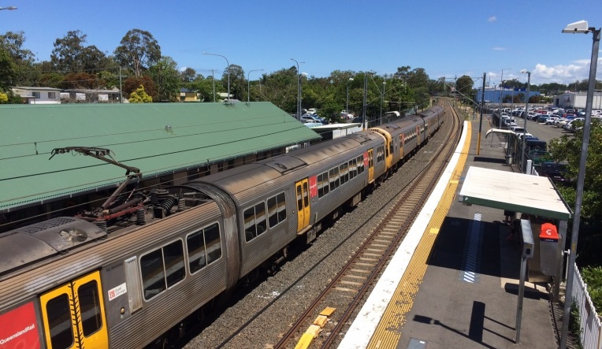

Delivery of Queensland Rail’s $300 million Station Accessibility Upgrade Program will mean about 83% of customers will travel to or from an accessible station.

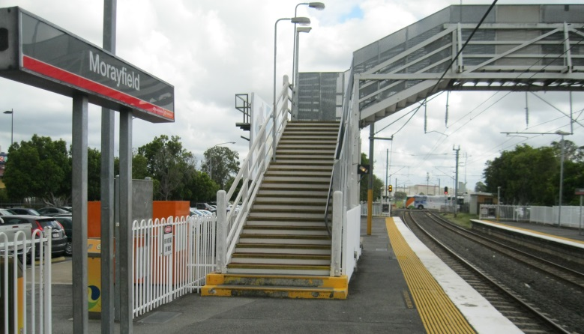

Construction impacts

Normal working hours are 6am to 5pm Monday to Saturday. Construction activities may involve:

noise associated with heavy machinery

temporary changes to access paths throughout the station precinct

changed traffic and parking conditions

increased vehicle movements near works

mobile lighting towers for night works.

Please take care around the work zones.

Queensland Rail thanks customers and the community for their cooperation during this important project.

Contact us

For more information or to provide feedback:

Phone: 1800 722 203 (free call)

Email: stationsupgrade@qr.com.au

Post: GPO Box 1429, Brisbane QLD 4000

Website: queenslandrail.com.au

