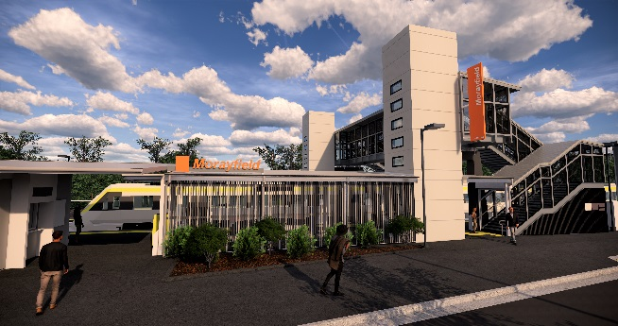
Morayfield station accessibility upgrade

PROJECT UPDATE – AUGUST 2019

Queensland Rail’s Morayfield station accessibility upgrade is part of the program to upgrade stations across the South East Queensland network, making them accessible for all customers.

Project progress
Activities undertaken recently at Morayfield have included:
- installation of platform roof structure and station building roofing
- pre-cast lift shafts and footbridge stairs
- electrical works.

Upcoming works
In the coming weeks, customers and the community can expect to see the following activities:
- platform raising and paving works
- lift shaft installation
- construction of western entry plaza and upgrade of footpath to platform 2
- station building – internal walls, fitting, tiling and ticket window
- service installations in footbridge and stairs
- shelter extension, roofing, lighting and services
- ongoing lift installation.

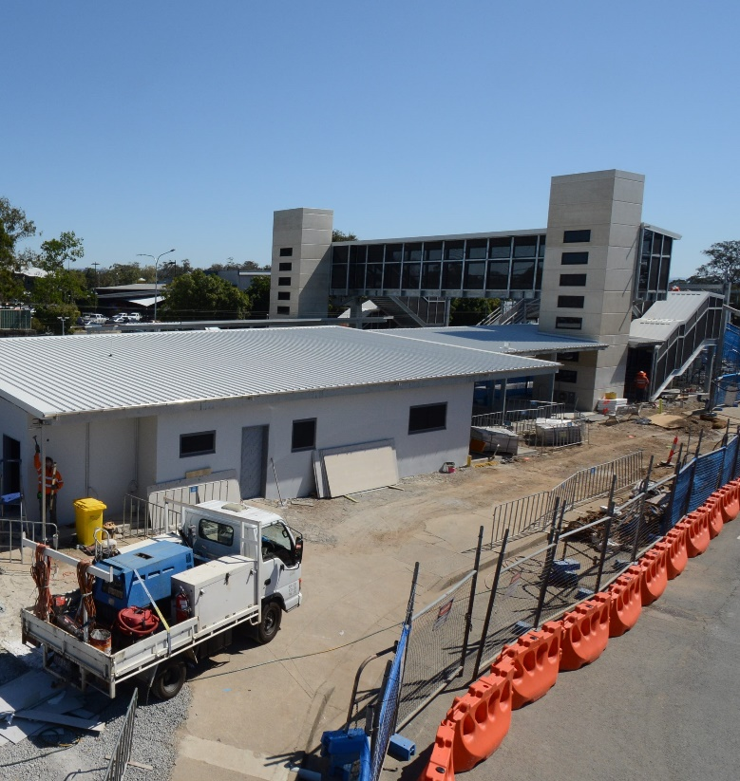
Please take care around the work zones.
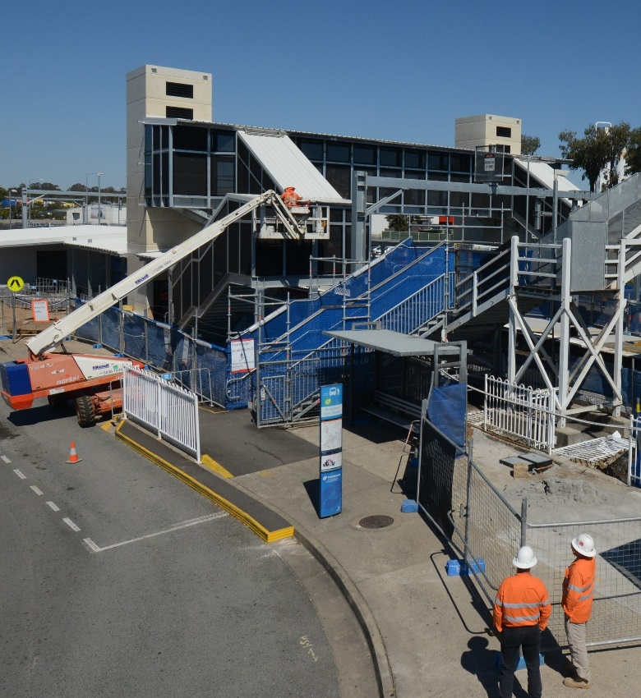

Construction impacts

Normal working hours are 6am to 5pm Monday to Saturday. Construction activities may involve:

noise associated with heavy machinery

temporary changes to station access paths

changed traffic and parking conditions

increased vehicle movements near works

mobile lighting towers for night works.

Residents and the local community will be given advance notification of construction activities likely to cause impacts, including after hours work (nights and Sundays, as required).

We thank you for your patience and cooperation as we work to improve your station.

Contact us

For more information or to provide feedback:

Phone: 1800 722 203 (free call)

Email: stationsupgrade@qr.com.au

Website: queenslandrail.com.au

