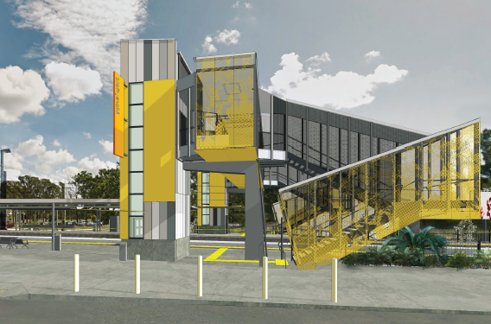
Morayfield station accessibility upgrade

PROJECT UPDATE – NOVEMBER 2018
The Morayfield station accessibility upgrade is part of Queensland Rail’s $300 million program to upgrade stations across the South East Queensland network, making them accessible for all customers.

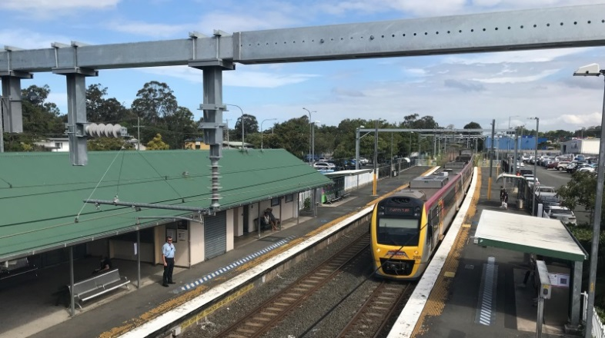

Project progress
Activities recently undertaken at Morayfield include:
- installation of safety fencing
- minor platform works, vegetation removal and relocation of ticketing and vending equipment
- contractor site establishment (off Visentin Road)
- return of student artwork (installed in 2006) to Morayfield East State School.

Upcoming works
In the coming weeks, customers and the community can expect to see the following activities:
- changes to station access and pedestrian pathways throughout the precinct
- realignment of footbridge stairs to enable construction on platform 1 (early November)
- station building demolition and associated works.

In addition to the accessibility upgrade works, Queensland Rail is also constructing a driveway to link the station carpark and the Caboolture Sports Club, providing overflow parking (pictured, below). Works are expected to be completed in approximately four to six weeks.
Please take care around the work zones.
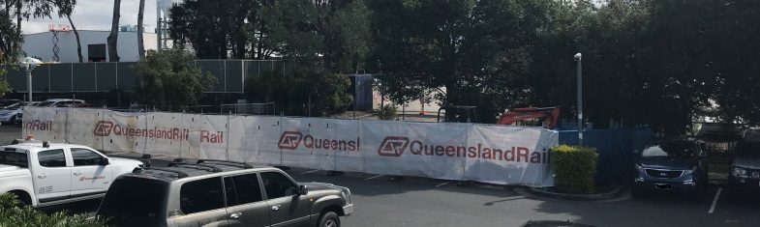
Driveway link to Caboolture Sports Club underway

Delivery of Queensland Rail’s $300 million Station Accessibility Upgrade Program will mean about 83% of customers will travel to or from an accessible station.

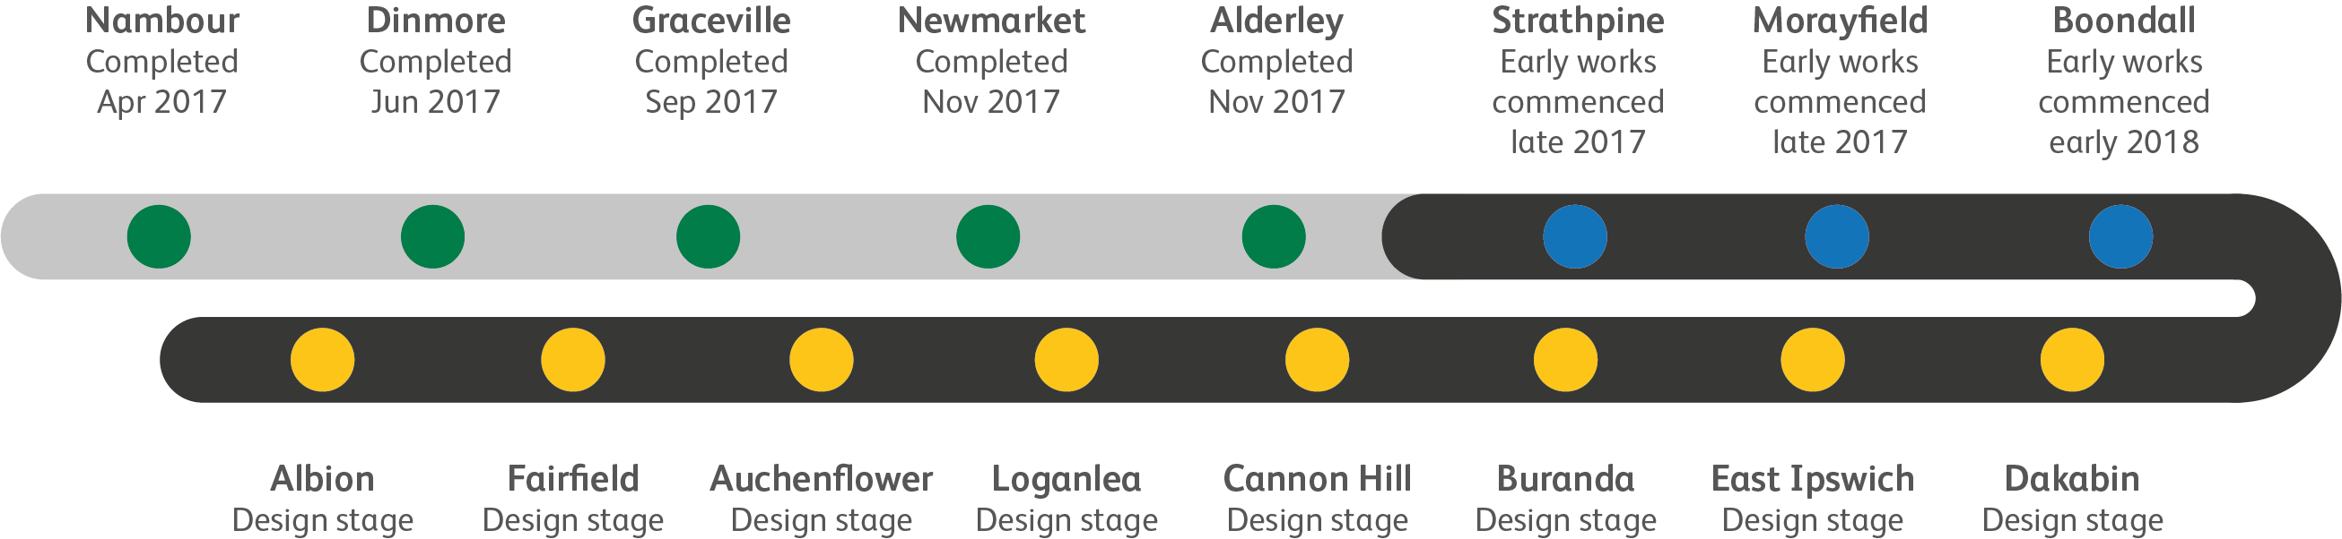

Construction impacts

Normal working hours are 6am to 5pm Monday to Saturday. Construction activities may involve:

noise associated with heavy machinery

temporary changes to station access paths

changed traffic and parking conditions

increased vehicle movements near works

mobile lighting towers for night works.

Residents and the local community will be given advance notification of construction activities likely to cause impacts, including after hours work (nights and Sundays, as required).

We thank customers and the community for your patience and cooperation as we work to improve your station.

Contact us

For more information or to provide feedback:

Phone: 1800 722 203 (free call)

Email: stationsupgrade@qr.com.au

Website: queenslandrail.com.au

