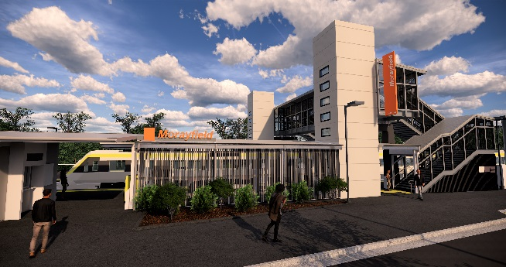

**Morayfield station accessibility upgrade**

**PROJECT UPDATE – NOVEMBER 2019**

**The Morayfield station accessibility upgrade is part of the State Government’s $357 million program to upgrade stations across the South East Queensland network, making them accessible for all customers.**

**Project progress**

Activities undertaken in October at Morayfield included:

* opening of new station building
* opening of the new footbridge to pedestrians (stair-only access until lift completion)
* ongoing lift installation
* completion of platform paving works – platform 2
* removal of the original timber footbridge.

**Upcoming works**

In the coming weeks, customers and the community can expect to see the following activities:

* removal of temporary facilities – eastern pathway (Caboolture-end)
* demolition of eastern pathway (Caboolture-end)
* completion of footpath upgrade – platform 2
* ongoing lift installation
* ongoing western entry works.

Please take care around the work zones.

# 

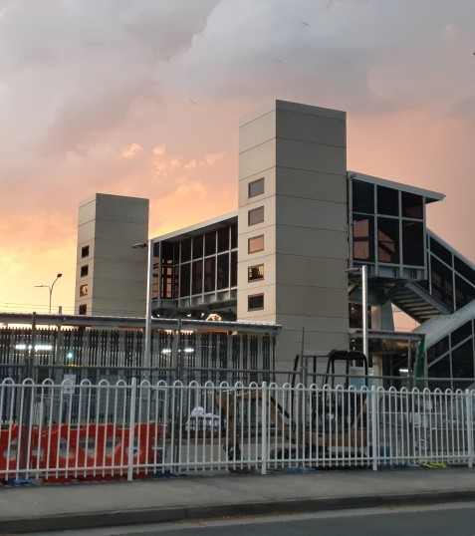

# Construction impacts

# Normal working hours are 6am to 5pm Monday to Saturday. Construction activities may involve:

# noise associated with heavy machinery

# temporary changes to station access paths

# changed traffic and parking conditions

# increased vehicle movements near works

# mobile lighting towers for night works.

# Residents and the local community will be given advance notification of construction activities likely to cause impacts, including after hours work (nights and Sundays, as required).

# We thank you for your patience and cooperation as we work to improve your station.

# Contact us

# For more information or to provide feedback:

# Phone: 1800 722 203 (free call)

# Email: stationsupgrade@qr.com.au

# Website: queenslandrail.com.au