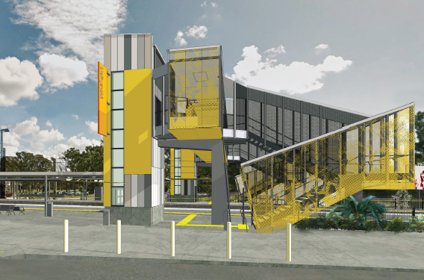
Morayfield station accessibility upgrade

PROJECT UPDATE – OCTOBER 2018

The Morayfield station accessibility upgrade is part of Queensland Rail’s $300 million program to upgrade stations across the South East Queensland network, making them accessible for all customers.

Project progress
Activities recently undertaken at Morayfield include:
- installation of temporary ticket office and toilet facilities
- opening of temporary ticket office (early October).

Upcoming works
In the near future, customers and the community can expect to see the following works:
- relocation of ticket machine and public telephone to platform 1 (near temporary ticket office) to enable construction works
- contractor site establishment for main construction works
- installation of temporary safety fencing and directional signage throughout site
- minor platform works
- changed station access and pedestrian pathways.

Please take care around the work zones.
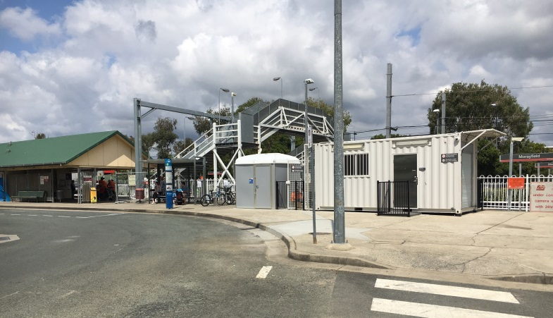

Temporary ticket office now open
Delivery of Queensland Rail’s $300 million Station Accessibility Upgrade Program will mean about 83% of customers will travel to or from an accessible station.

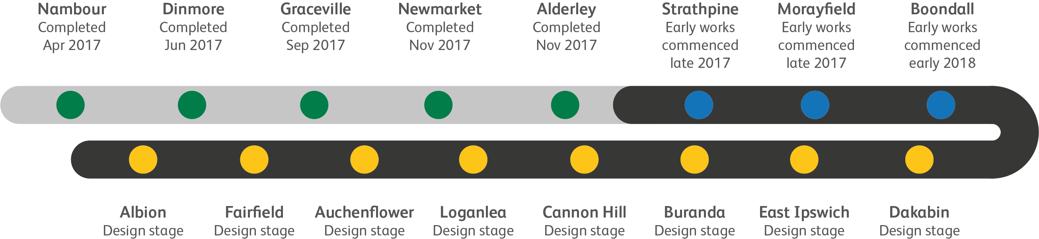
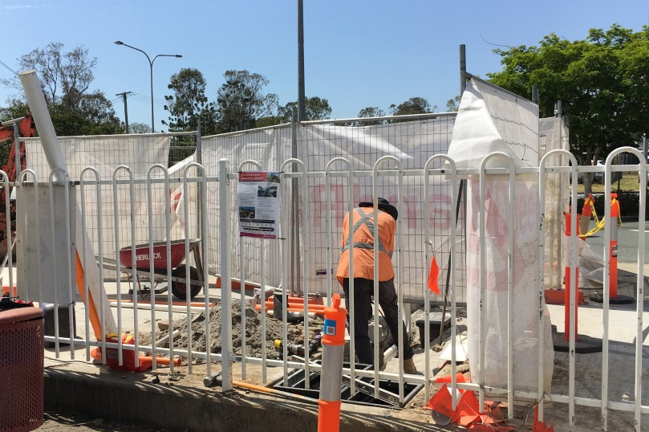
Preparatory works for temporary ticket office

Construction impacts

Normal working hours are 6am to 5pm Monday to Saturday. Construction activities may involve:

noise associated with heavy machinery

temporary changes to station access paths

changed traffic and parking conditions

increased vehicle movements near works

mobile lighting towers for night works.

We thank customers and the community for their patience and cooperation during this important project.

Contact us

For more information or to provide feedback:

Phone: 1800 722 203 (free call)

Email: stationsupgrade@qr.com.au

Website: queenslandrail.com.au

