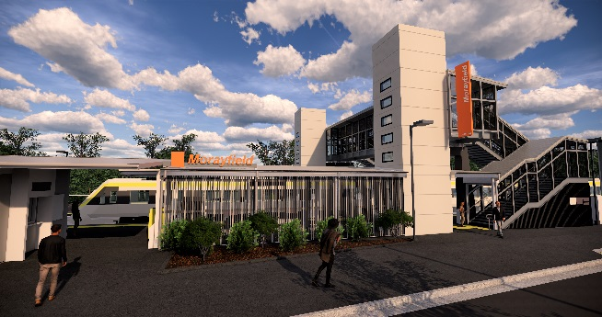

**Morayfield station accessibility upgrade**

**PROJECT UPDATE – OCTOBER 2019**

**The Morayfield station accessibility upgrade is part of the State Government’s $357 million program to upgrade stations across the South East Queensland network, making them accessible for all customers.**

**Project progress**

Activities undertaken in September at Morayfield included:

* progression of station building works
* completion of platform paving works – platform 1
* construction of western entry plaza and upgrade of footpath to platform 2 and lighting
* service installations in footbridge and stairs
* bridge flooring works
* ongoing lift installation.

**Upcoming works**

In the coming weeks, customers and the community can expect to see the following activities:

* opening of new station building
* opening of the new footbridge to pedestrians (stair-only access until lift completion)
* ongoing lift installation
* completion of upgrade of footpath – platform 2
* completion of platform paving works – platform 2
* removal of the original timber footbridge.

Please take care around the work zones.

The station’s platforms will be closed for uninterrupted works from 11.30pm Friday 25 until 4am Monday 28 October. Rail services will not stop at Morayfield during this time. Half-hourly shuttle bus services will take customers to Caboolture to connect with all services (allow an additional 30 minutes’ travel time).

# 

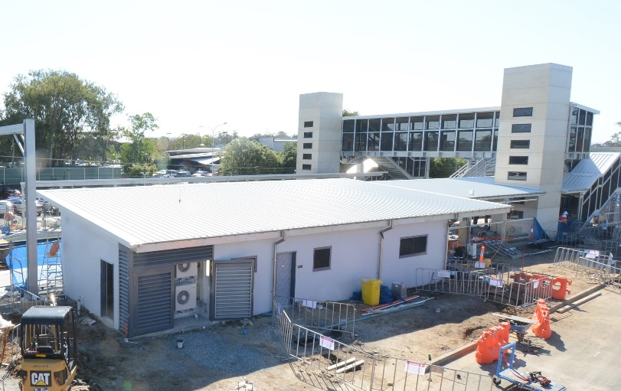

# Construction impacts

# Normal working hours are 6am to 5pm Monday to Saturday. Construction activities may involve:

# noise associated with heavy machinery

# temporary changes to station access paths

# changed traffic and parking conditions

# increased vehicle movements near works

# mobile lighting towers for night works.

# Residents and the local community will be given advance notification of construction activities likely to cause impacts, including after hours work (nights and Sundays, as required).

# We thank you for your patience and cooperation as we work to improve your station.

# Contact us

# For more information or to provide feedback:

# Phone: 1800 722 203 (free call)

# Email: stationsupgrade@qr.com.au

# Website: queenslandrail.com.au