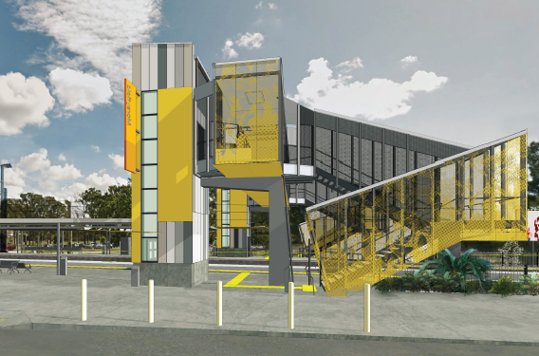
Morayfield station accessibility upgrade

PROJECT UPDATE – SEPTEMBER 2018

The Morayfield station accessibility upgrade is part of Queensland Rail’s $300 million program to upgrade stations across the South East Queensland network, making them accessible for all customers.

Project progress
Activities recently undertaken at Morayfield include:
- Moreton Bay Regional Council plumbing approvals for the temporary ticket office
- temporary toilet facilities ordered, ready for installation late September
- set up of initial project safety fencing.

Upcoming works
In the near future, customers and the community can expect to see the following works:
- site establishment and safety fencing
- installation of temporary ticket office and toilet, (excavation, plumbing and electrical works)
- commissioning of temporary ticket office
- relocation of the platform 2 ticket machine and public telephone to platform 1, near the ticket office.
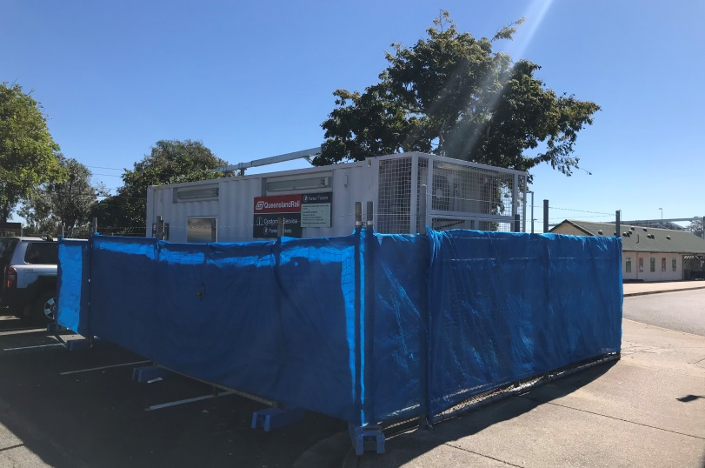
Temporary ticket office being prepared for installation

Delivery of Queensland Rail’s $300 million Station Accessibility Upgrade Program will mean about 83% of customers will travel to or from an accessible station.

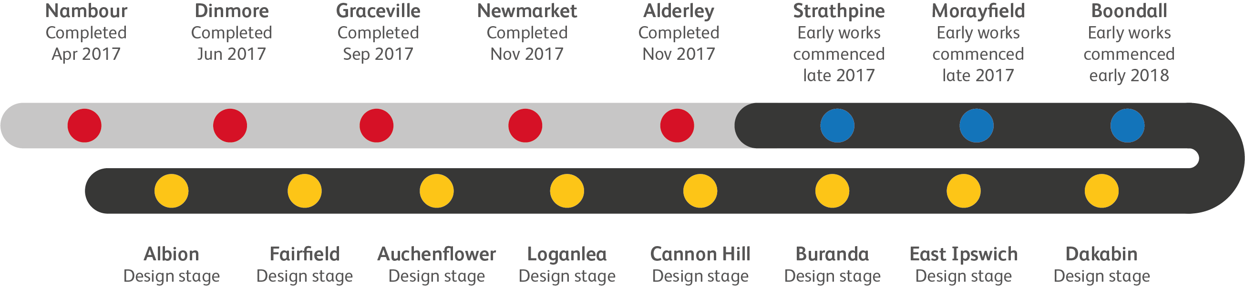
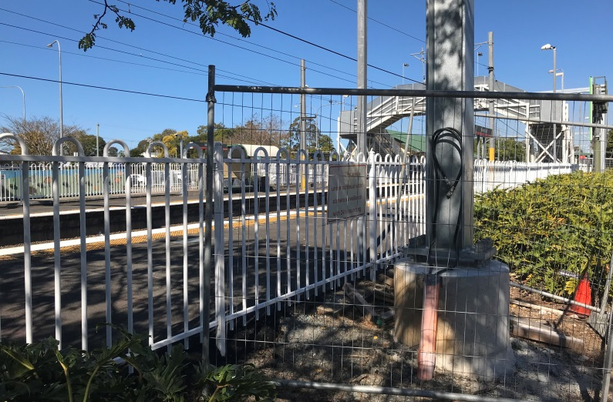

Early works: overhead mast relocation

Construction impacts

Normal working hours are 6am to 5pm Monday to Saturday. Construction activities may involve:

noise associated with heavy machinery

temporary changes to station access paths

changed traffic and parking conditions

increased vehicle movements near works

mobile lighting towers for night works.

Please take care around the work zones.

Queensland Rail thanks customers and the community for their patience and cooperation during this important project.

Contact us

For more information or to provide feedback:

Phone: 1800 722 203 (free call)

Email: stationsupgrade@qr.com.au

Website: queenslandrail.com.au

