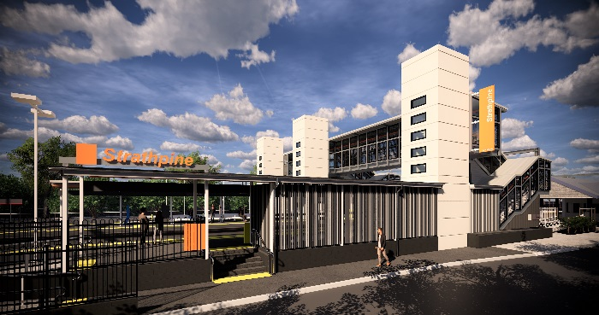
Strathpine station accessibility upgrade

PROJECT UPDATE – APRIL 2019

The Strathpine station accessibility upgrade is part of Queensland Rail’s $300 million program to upgrade stations across the South East Queensland network, making them accessible for all customers.

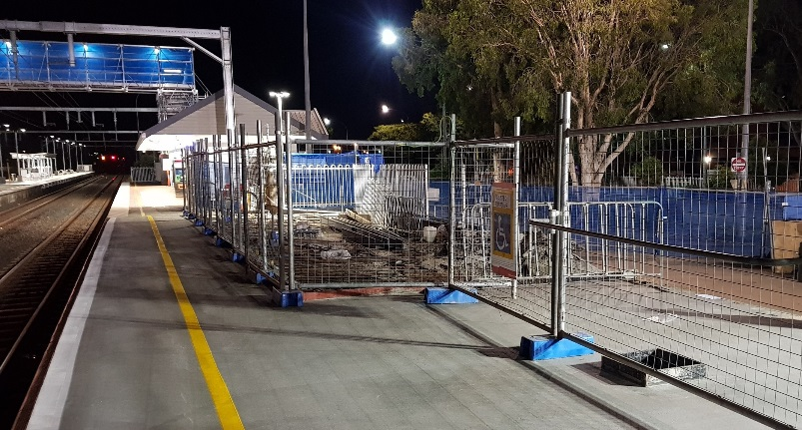
Raised platform 1 – temporary surface

Project progress
In March, the following activities were undertaken at Strathpine:
- lift shaft walls (formwork, reinforcement and concrete) – platform 1
- screw piling for footbridge and lift shaft – platform 1
- foundations and footings – platform 2/3
- raised section of platform 1 – concrete pour (pictured).

Upcoming works
This month, customers and the community can expect to see the following activities:
- changes to work zone footprint to facilitate construction – western carpark
- screw piling for footbridge footings – platform 2/3
- concrete pour – platform 2/3
- commence installation of lift shaft segments.
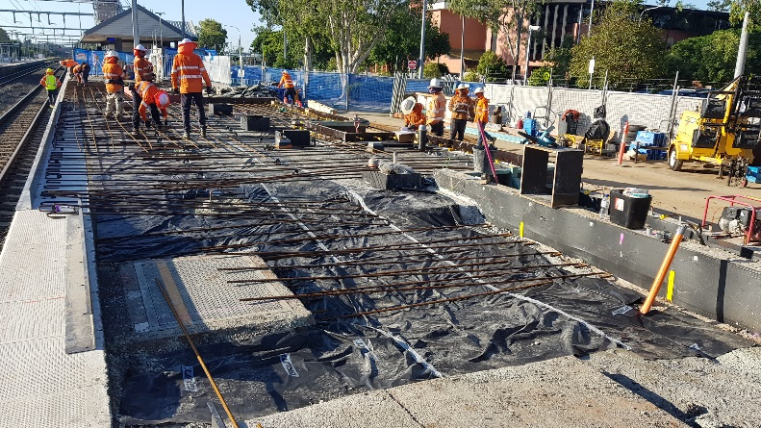
Platform raising works

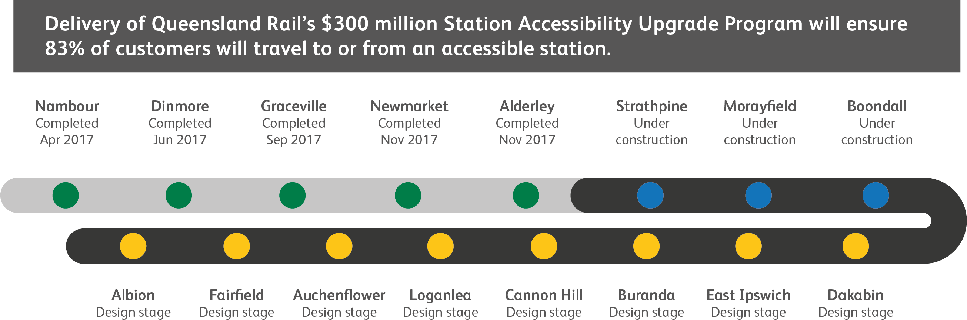

Construction impacts

Normal working hours are 6am to 5pm Monday to Saturday. Construction activities may involve

noise associated with heavy machinery

temporary changes to access paths throughout the station precinct

ramp access to platform 2/3 (at level crossing) closed throughout construction

changed traffic and parking conditions

increased vehicle movements near works

mobile lighting towers for night works.

Please follow all directional signage and take care around the work zones.

We thank customers and the community for your patience and cooperation as we work to improve your station.

Contact us

For more information or to provide feedback:

Phone: 1800 722 203 (free call)

Email: stationsupgrade@qr.com.au

Website: queenslandrail.com.au

