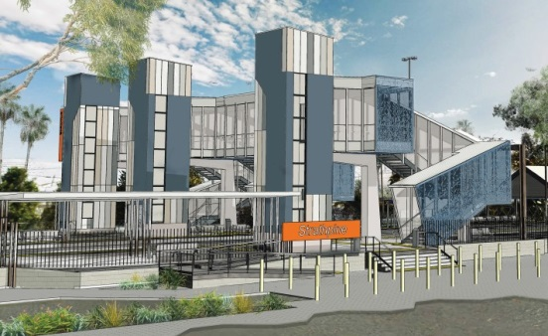
Strathpine station accessibility upgrade

PROJECT UPDATE – AUGUST 2018

The Strathpine station accessibility upgrade is part of Queensland Rail’s $300 million program to upgrade stations across the South East Queensland network, making them accessible for all customers.

Early works to date
Since site establishment in late 2017, early works have included:
- relocation of overhead electrification equipment
- construction of the temporary platform
- some tree clearing in the western carpark.

Upcoming works
This month, customers and the community can expect to see the following construction activities:
- contractor site establishment
- project compound and safety fencing
- preparations for the temporary footbridge installation (mid-August)
- changes to some parking to enable works.

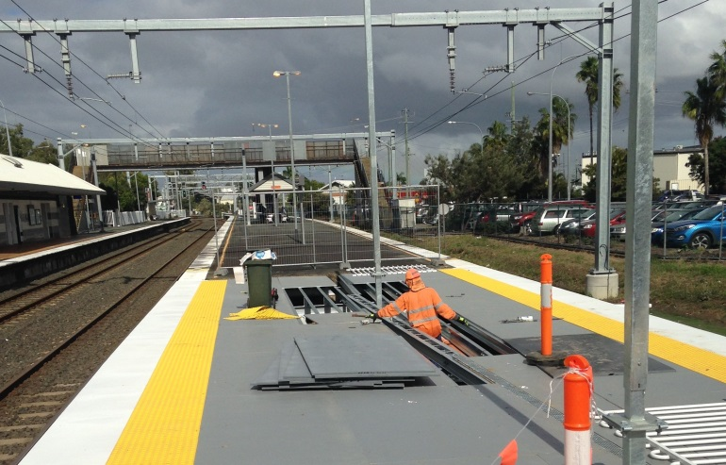
Please follow all directional signage and take care around the work zones.
Platform works, July 2018.

Delivery of Queensland Rail’s $300 million Station Accessibility Upgrade Program will mean about 83% of customers will travel to or from an accessible station.

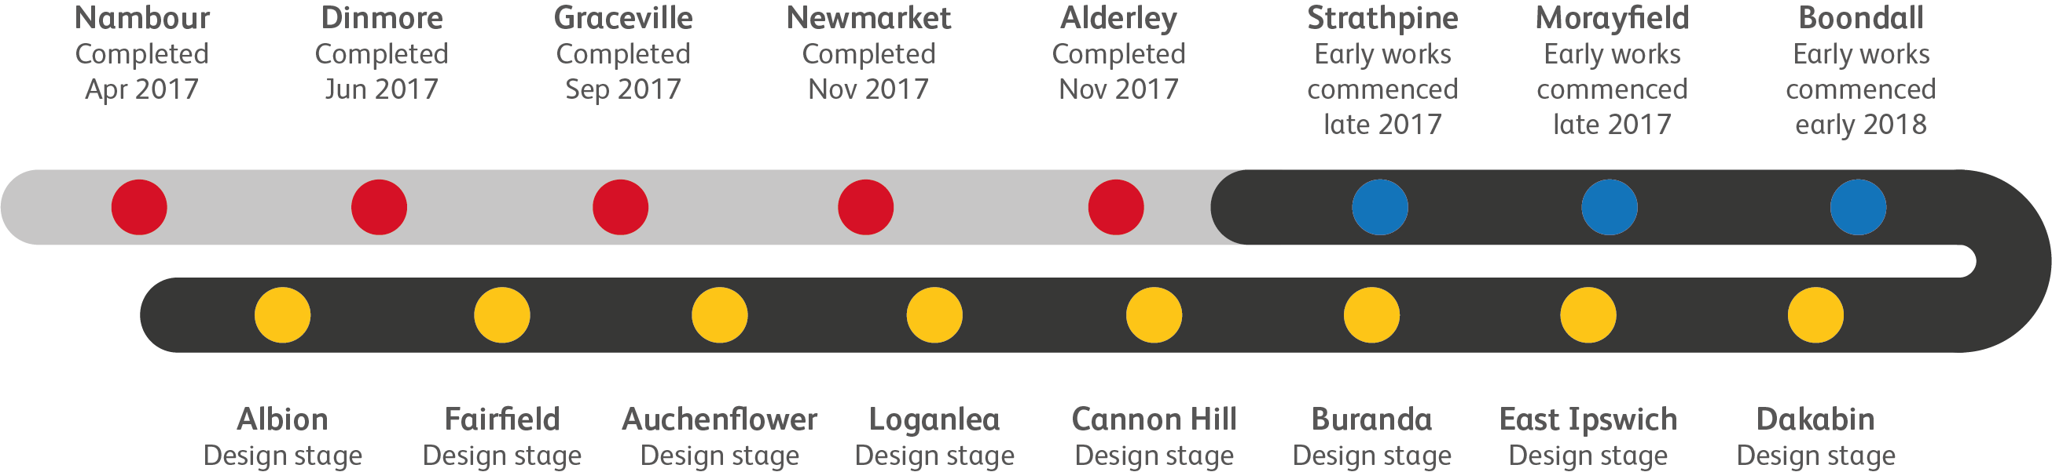
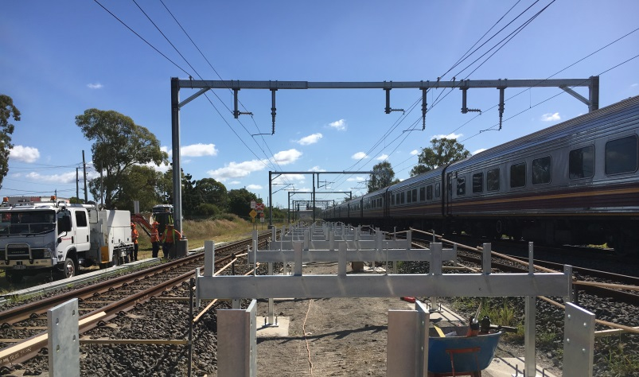

Temporary platform under construction.

Construction impacts

Normal working hours are 6am to 5pm Monday to Saturday. Construction activities may involve:

noise associated with heavy machinery

temporary changes to access paths throughout the station precinct

changed traffic and parking conditions

increased vehicle movements near works

mobile lighting towers for night works.

Queensland Rail thanks customers and the community for their cooperation during this important project.

Contact us

For more information or to provide feedback:

Phone: 1800 722 203 (free call)

Email: stationsupgrade@qr.com.au

Post: GPO Box 1429, Brisbane QLD 4000

Website: queenslandrail.com.au

