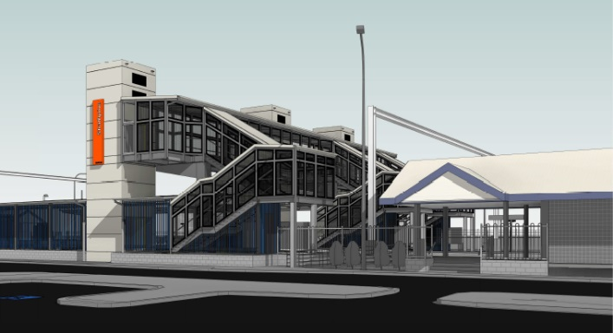
Strathpine station accessibility upgrade

PROJECT UPDATE – DECEMBER 2018

The Strathpine station accessibility upgrade is part of Queensland Rail’s $300 million program to upgrade stations across the South East Queensland network, making them accessible for all customers.

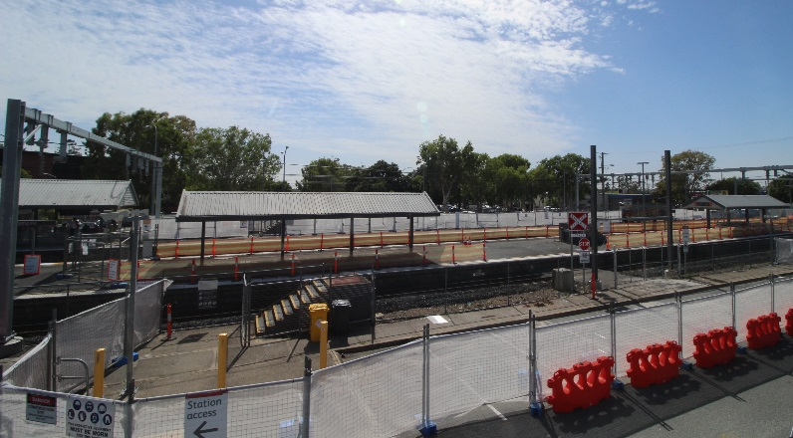

Project progress
During November the following activities were undertaken:
- geotechnical surveys – station and carpark areas
- electrical/communications service identification, relocation and removal under platform 2/3
- vegetation removal for new platform 1 entrance ramp
- preparation for main construction works.

The ramp to platform 2/3 (at South Pine Road level crossing) is closed during construction. Please see station staff if you require assistance accessing the station or boarding services.
Upcoming works
In December, customers and the community can expect to see the following activities:
- installation of temporary construction access across track
- demolition works on platform 2/3 – removal of original footbridge staircase bases and shelter.
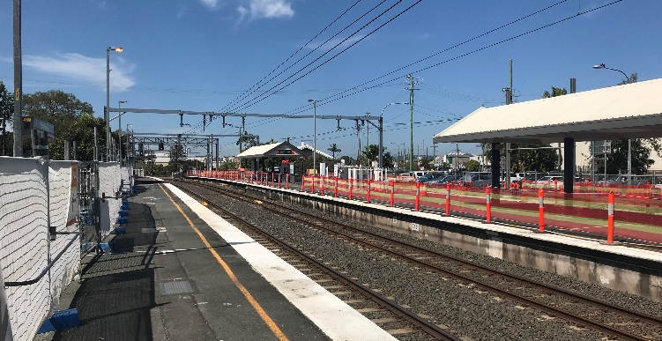
Preparation works for main construction, platform 2/3

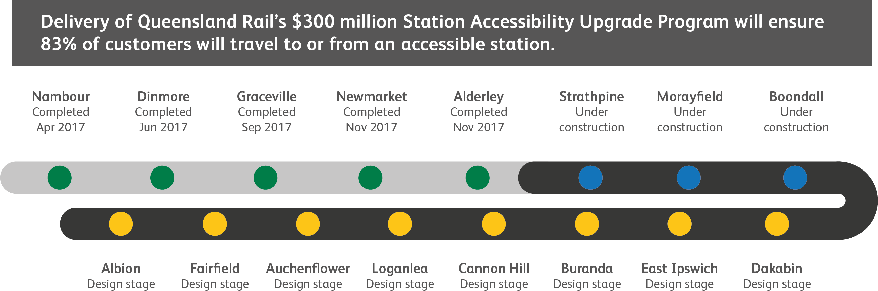

Site of new access ramp, platform 2/3

Construction impacts

Normal working hours are 6am to 5pm Monday to Saturday. Construction activities may involve:

noise associated with heavy machinery

temporary changes to access paths throughout the station precinct

changed traffic and parking conditions

increased vehicle movements near works

mobile lighting towers for night works.

Please follow all directional signage and take care around the work zones.

We thank customers and the community for your patience and cooperation as we work to improve your station.

Contact us

For more information or to provide feedback:

Phone: 1800 722 203 (free call)

Email: stationsupgrade@qr.com.au

Website: queenslandrail.com.au

