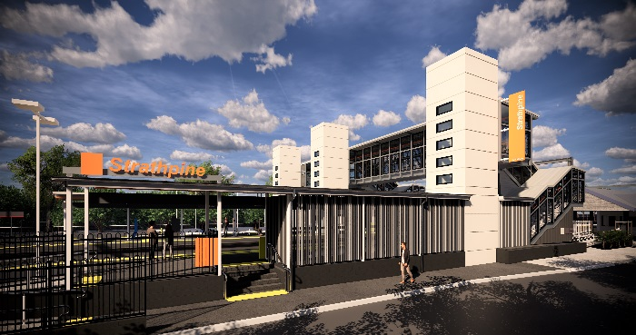
Strathpine station accessibility upgrade

PROJECT UPDATE – DECEMBER 2019

The Strathpine station accessibility upgrade is part of the State Government’s $357 million investment to upgrade stations across the South East Queensland network, making them accessible for all customers.

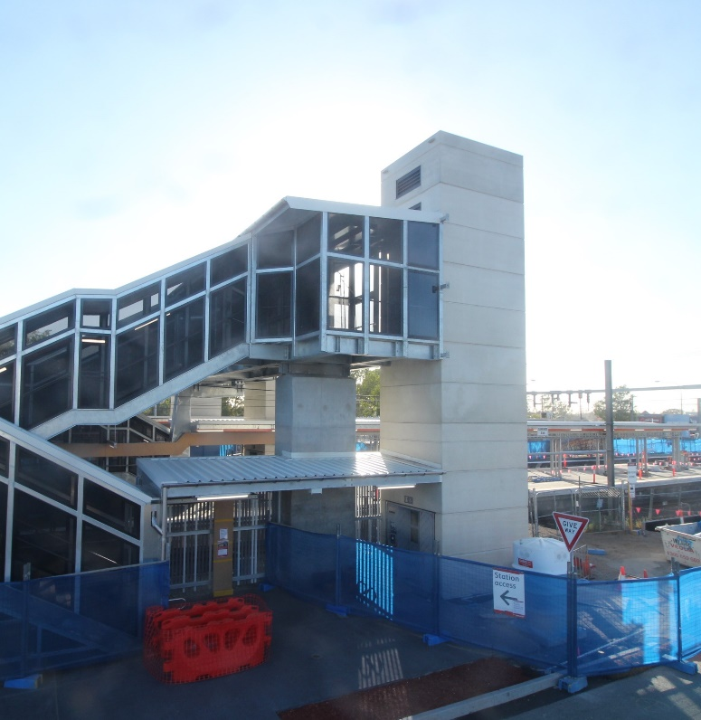

Project progress
The following activities were undertaken at Strathpine in November:
- completion of bicycle enclosure structural steel
- access roadworks – eastern carpark
- entrance fencing – platform 1
- lighting and signage works
- ongoing lift installation.

Upcoming works
In the coming weeks, customers and the community can expect to see the following activities:
- eastern entry and landscaping works
- ongoing lift installation
- bicycle enclosure fit out
- western carpark lighting installation
- platform resurfacing works
- removal of decommissioned ramp – platform 2/3.

Please follow all directional signage and take care around the work zones.
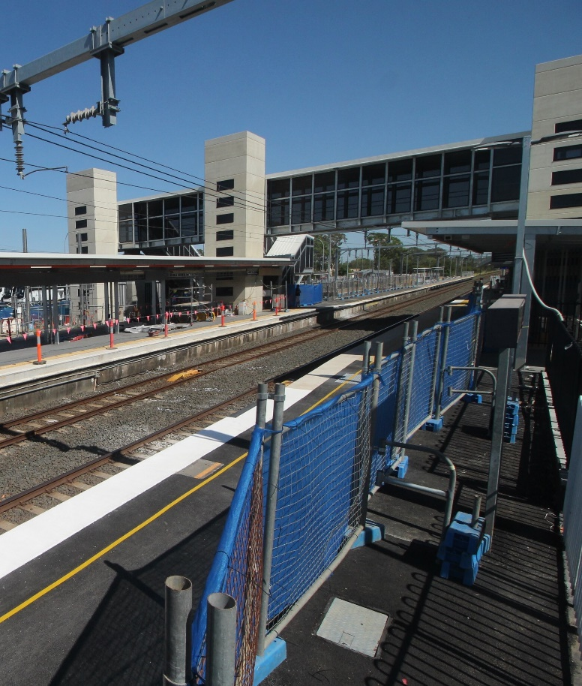

Construction impacts

Normal working hours are 6am to 5pm, Monday to Saturday. Construction activities may involve:

noise associated with heavy machinery

temporary changes to access paths throughout the station precinct

ramp access to platform 2/3 (at level crossing) closed (non-compliant ramp to be removed)

changed traffic and parking conditions

increased vehicle movements near works

mobile lighting towers for night works.

Thank you for your patience and cooperation as we work to improve your station.

Project activities will shut down briefly over the Christmas period. Works will resume in early January 2020.

Queensland Rail and the project team wish you season’s greetings and a safe and happy holiday period.

Contact us

For more information or to provide feedback:

Phone: 1800 722 203 (free call)

Email: stationsupgrade@qr.com.au

Website: queenslandrail.com.au

