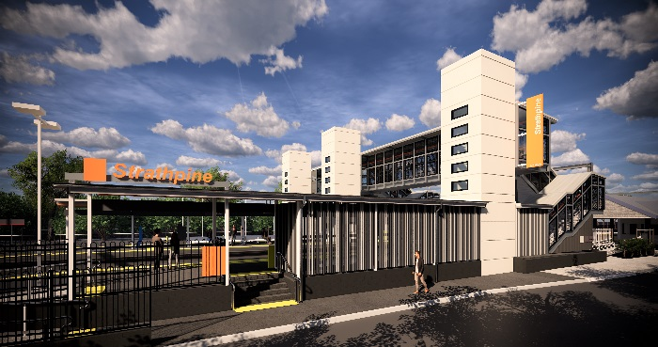
Strathpine station accessibility upgrade

PROJECT UPDATE – FEBRUARY 2019

The Strathpine station accessibility upgrade is part of Queensland Rail’s $300 million program to upgrade stations across the South East Queensland network, making them accessible for all customers.

Project progress
During January, the following activities were undertaken at Strathpine:
- completion of temporary construction access across track
- demolition works – original staircase bases
- excavation and major piling (foundation) works for new lift shaft (western carpark).

Upcoming works
This month, customers and the community can expect to see the following activities:
- excavations and screw piling for foundations for raised section of platform 1
- preparatory excavations to platform 2/3
- service conduit relocations – platform 1.

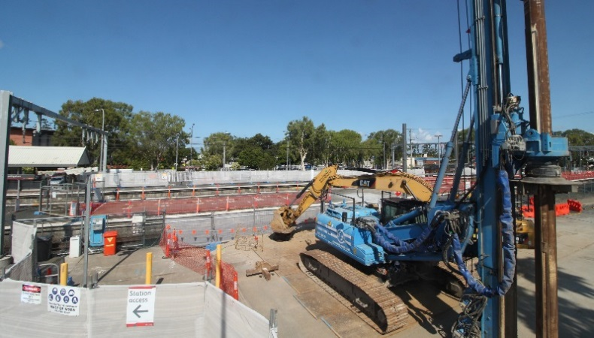
Please follow all directional signage and take care around the work zones.

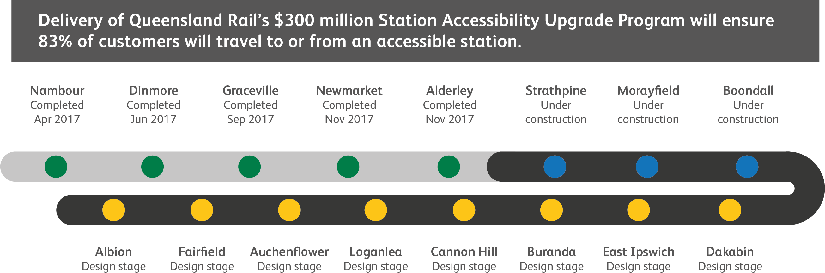

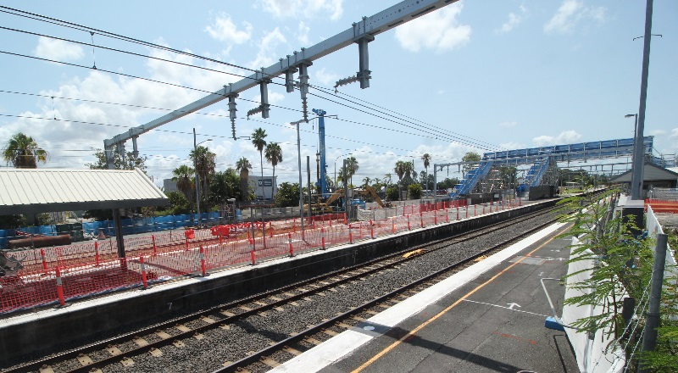

Construction impacts

Normal working hours are 6am to 5pm Monday to Saturday. Construction activities may involve:

noise associated with heavy machinery

temporary changes to access paths throughout the station precinct

ramp access to platform 2/3 (at level crossing) closed during construction

changed traffic and parking conditions

increased vehicle movements near works

mobile lighting towers for night works.

We thank customers and the community for your patience and cooperation as we work to improve your station.

Contact us

For more information or to provide feedback:

Phone: 1800 722 203 (free call)

Email: stationsupgrade@qr.com.au

Website: queenslandrail.com.au

