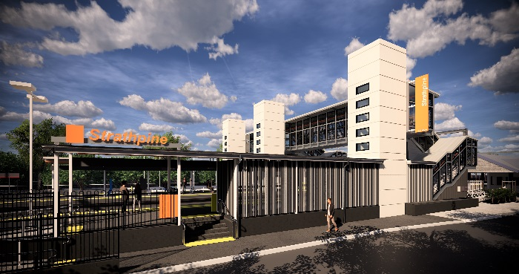
Strathpine station accessibility upgrade

PROJECT UPDATE – JULY 2019

Queensland Rail’s Strathpine station accessibility upgrade is part of the program to upgrade stations across the South East Queensland network, making them accessible for all customers.

Project progress
Last month, the following activities were undertaken:
- installation of lift shafts – platform 1 and western carpark
- installation of footbridge stairs – platform 1 and western carpark
- demolition of redundant structures – platform 2/3
- ongoing excavation works – platform 2/3.

Upcoming works
In the coming weeks, customers and the community can expect to see the following activities:
- installation of new waiting shelters
- drainage and surface works – platform 2/3
- construction of new accessible entrance – platform 1.

Please follow all directional signage and take care around the work zones.

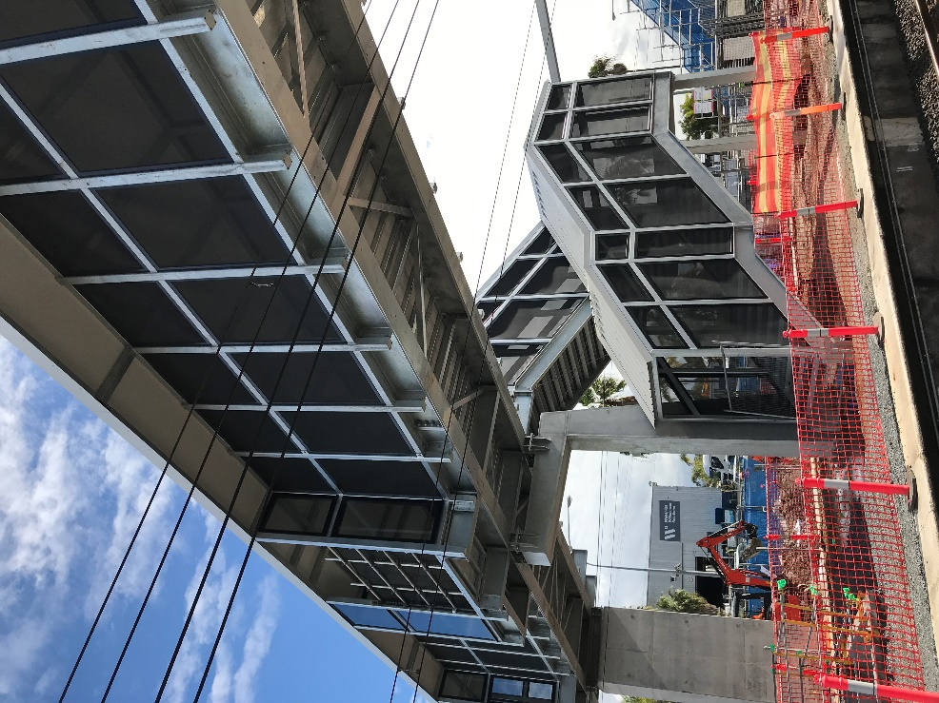

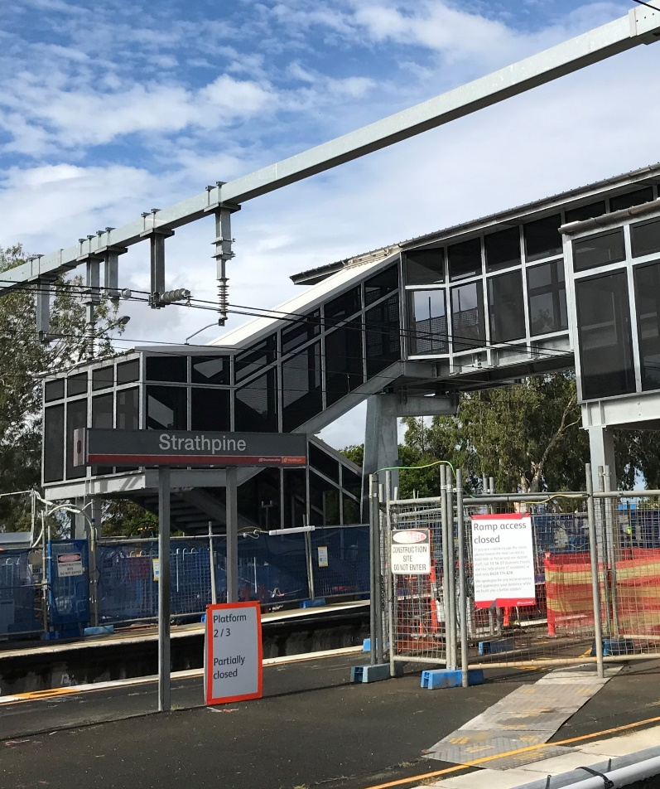

Construction impacts

Normal working hours are 6am to 5pm, Monday to Saturday. Construction activities may involve:

noise associated with heavy machinery

temporary changes to access paths throughout the station precinct

ramp access to platform 2/3 (at level crossing) closed throughout construction

changed traffic and parking conditions

increased vehicle movements near works

mobile lighting towers for night works.

Thank you for your patience and cooperation as we work to improve your station.

Contact us

For more information or to provide feedback:

Phone: 1800 722 203 (free call)

Email: stationsupgrade@qr.com.au

Website: queenslandrail.com.au

