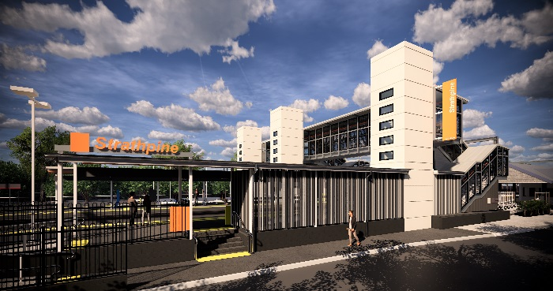
Strathpine station accessibility upgrade

PROJECT UPDATE – MARCH 2020

The Strathpine station accessibility upgrade is part of the State Government’s $357 million investment to upgrade stations across the South East Queensland network, making them accessible for all customers.

Project progress
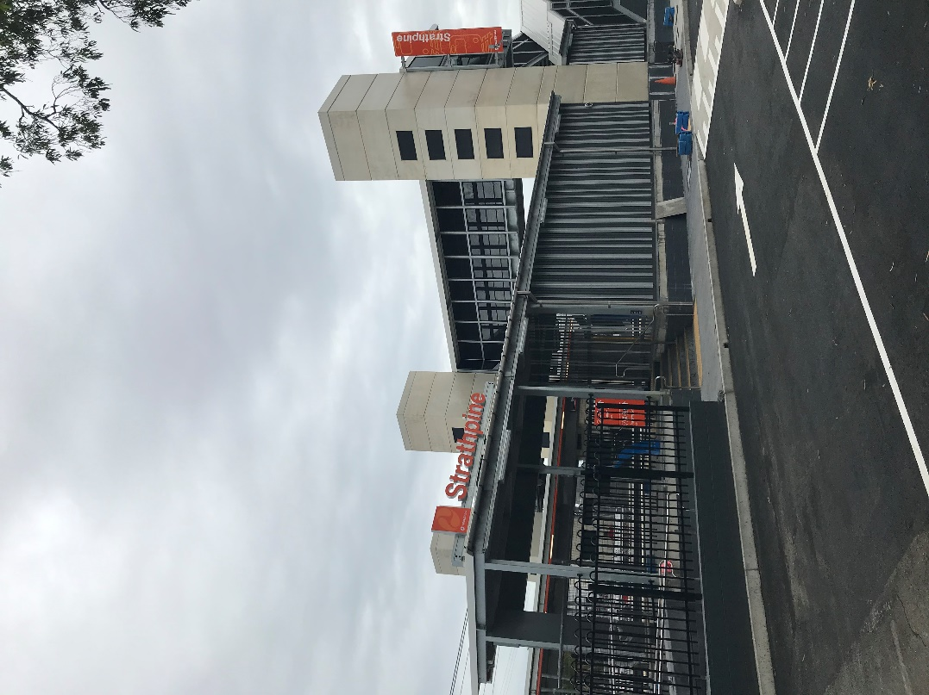
During the last month, the following activities were undertaken at Strathpine:
- completion of upgraded platform 2/3
- commenced dismantling and removal of temporary platform
- completion of eastern entry and landscaping works
- ongoing bicycle enclosure fit-out
- provision of accessible parking – western carpark
- stormwater drainage works.

Upcoming works
In the coming weeks, customers and the community can expect to see the following activities:
- removal of temporary platform structure
- bicycle enclosure commissioning
- other minor works.

Please follow all directional signage and take care around the work zones.
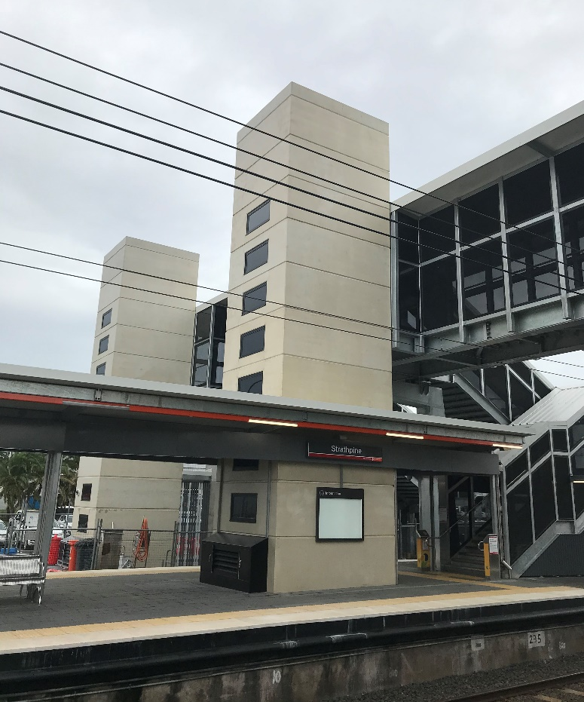

Construction impacts

Normal working hours are 6am to 5pm, Monday to Saturday. Construction activities may involve:

noise associated with heavy machinery

temporary changes to access paths throughout the station precinct

changed traffic and parking conditions

increased vehicle movements near works

mobile lighting towers for night works.

Thank you for your patience and cooperation as we work to improve your station.

Contact us

For more information or to provide feedback:

Phone: 1800 722 203 (free call)

Email: stationsupgrade@qr.com.au

Website: queenslandrail.com.au

