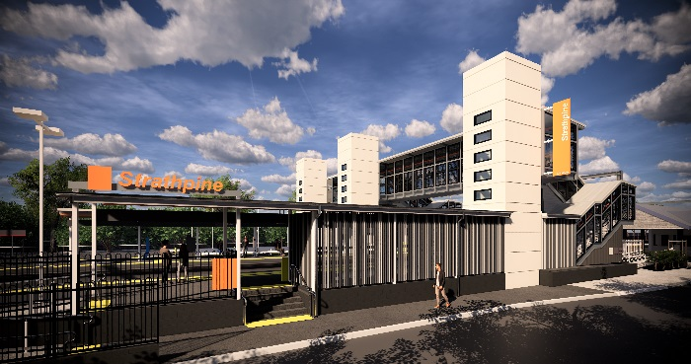
Strathpine station accessibility upgrade

PROJECT UPDATE – MAY 2019

The Strathpine station accessibility upgrade is part of Queensland Rail’s $300 million program to upgrade stations across the South East Queensland network, making them accessible for all customers.

Project progress
In April, the following activities were undertaken at Strathpine:
- changes to work zone footprint to facilitate construction – western carpark
- foundations for footbridge footings – platform 2/3
- construction of lift shaft segments (offsite).

Upcoming works
In the coming weeks, customers and the community can expect to see the following activities:
- works to underground services including tree removal – eastern carpark
- concrete pour for lift shaft walls – platforms 1 and 2/3
- concrete pour for footbridge and stairs footings – platform 2/3
- concrete pour for footbridge support column – western carpark.

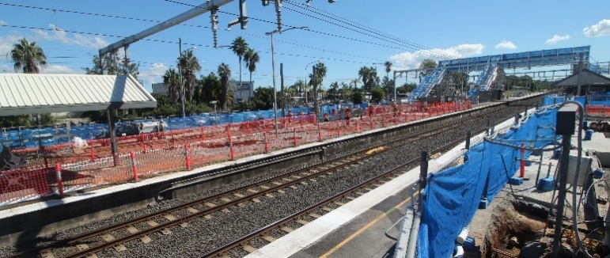
To enable assembly and installation of the new footbridge in early June, the western carpark will be closed from Saturday 18 May to Monday 3 June.

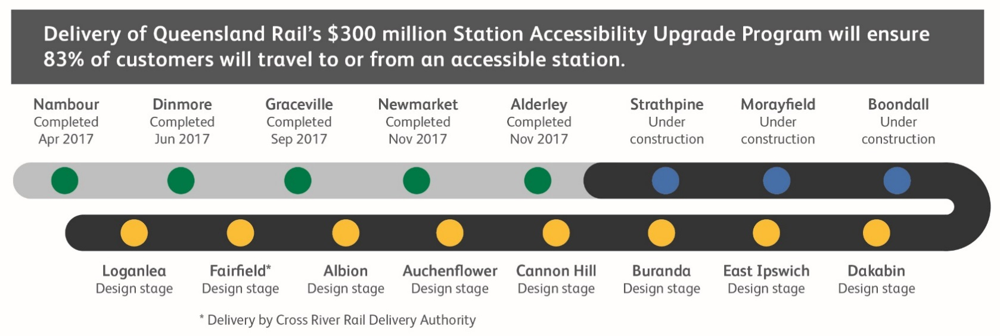

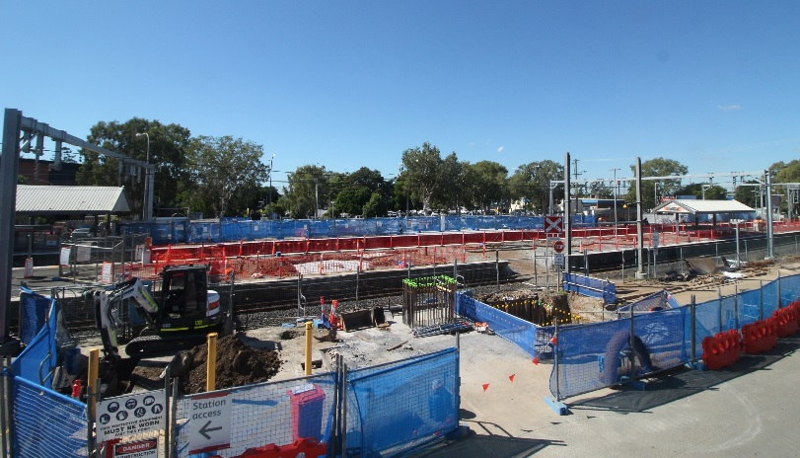

Construction impacts

Normal working hours: 6am to 5pm Monday to Saturday. Construction activities may involve:

noise associated with heavy machinery

temporary changes to access paths throughout the station precinct

ramp access to platform 2/3 (at level crossing) closed throughout construction

changed traffic and parking conditions

increased vehicle movements near works

mobile lighting towers for night works.

Please follow all directional signage and take care around the work zones. We thank you for your patience and cooperation as we work to improve your station.

Contact us

For more information or to provide feedback:

Phone: 1800 722 203 (free call)

Email: stationsupgrade@qr.com.au

Website: queenslandrail.com.au

