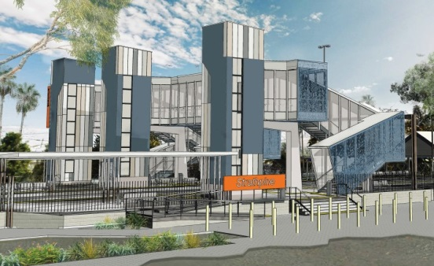
Strathpine station accessibility upgrade

PROJECT UPDATE – NOVEMBER 2018

The Strathpine station accessibility upgrade is part of Queensland Rail’s $300 million program to upgrade stations across the South East Queensland network, making them accessible for all customers.

Project progress
The following activities were recently undertaken:
- minor demolition works
- electrical/communications service identification, relocation and removal to enable construction
- tree clearing adjacent to platform 1 for new entrance ramp
- preparations for main construction works.

The ramp to platform 2/3 (at South Pine Road level crossing) is now closed for construction. Please see station staff if you require assistance accessing the station or boarding services.
Upcoming works
In the coming weeks, customers and the community can expect to see the following activities:
- commencement of main construction works
- vegetation removal – Station Street carpark entry
- demolition works on platform 2/3, including the removal of original footbridge staircase bases.
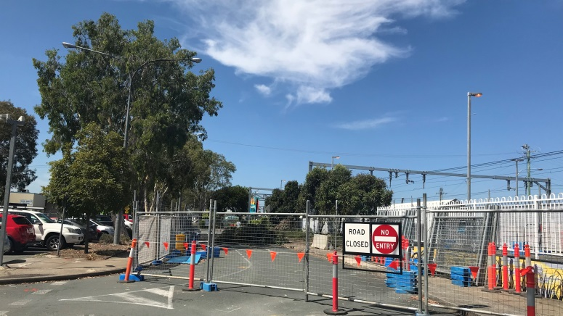
Temporary carpark changes – new entry works

Delivery of Queensland Rail’s $300 million Station Accessibility Upgrade Program will mean about 83% of customers will travel to or from an accessible station.

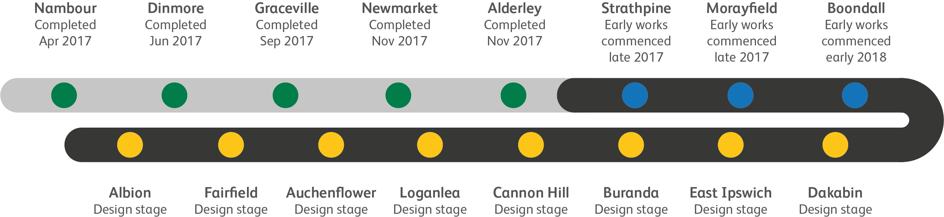
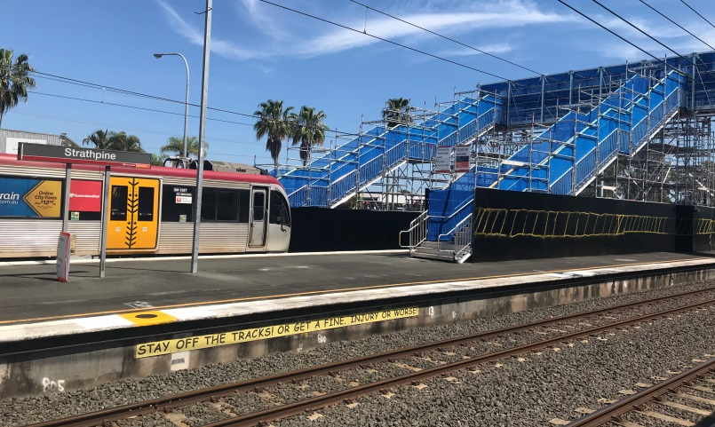

Construction impacts

Normal working hours are 6am to 5pm Monday to Saturday. Construction activities may involve:

noise associated with heavy machinery

temporary changes to access paths throughout the station precinct

changed traffic and parking conditions

increased vehicle movements near works

mobile lighting towers for night works.

Please follow all directional signage and take care around the work zones.

We thank customers and the community for your patience and cooperation as we work to improve your station.

Contact us

For more information or to provide feedback:

Phone: 1800 722 203 (free call)

Email: stationsupgrade@qr.com.au

Website: queenslandrail.com.au

