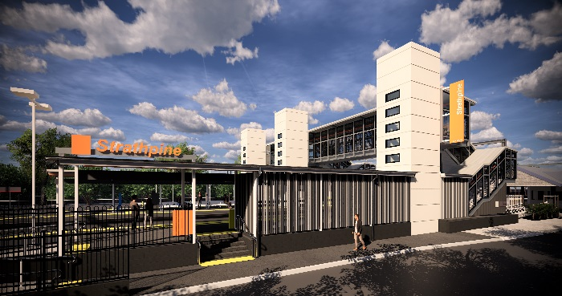
Strathpine station accessibility upgrade

PROJECT UPDATE – NOVEMBER 2019

The Strathpine station accessibility upgrade is part of the State Government’s $357 million program to upgrade stations across the South East Queensland network, making them accessible for all customers.

Project progress
In recent weeks, the following activities were undertaken at Strathpine:
- opening of the new footbridge (stair-only access until lift completion)
- commencement of bicycle enclosure works
- paving – platform 2/3
- shelter works – platform 2/3
- lighting installations – platform 2/3
- ongoing lift installation
- removal of the temporary footbridge.

Upcoming works
In the coming weeks, customers and the community can expect to see the following activities:
- completion of bicycle enclosure structural steel
- access roadworks – eastern carpark
- entrance fencing – platform 1
- lighting and signage works
- ongoing lift installation
- paving works – platform 2/3.

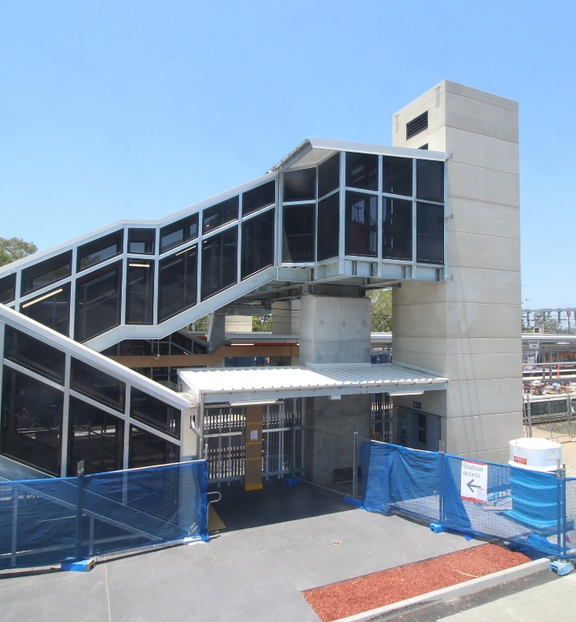
Please follow all directional signage and take care around the work zones.

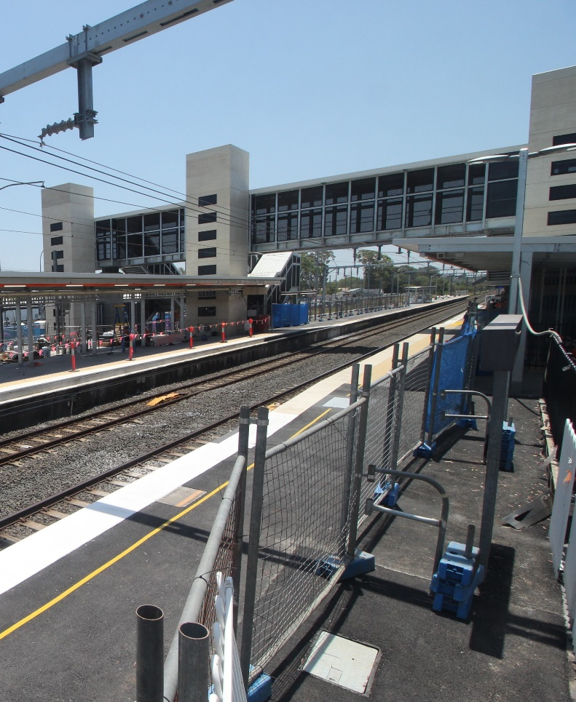

Construction impacts

Normal working hours are 6am to 5pm, Monday to Saturday. Construction activities may involve:

noise associated with heavy machinery

temporary changes to access paths throughout the station precinct

ramp access to platform 2/3 (at level crossing) closed

changed traffic and parking conditions

increased vehicle movements near works

mobile lighting towers for night works.

Thank you for your patience and cooperation as we work to improve your station.

Contact us

For more information or to provide feedback:

Phone: 1800 722 203 (free call)

Email: stationsupgrade@qr.com.au

Website: queenslandrail.com.au

