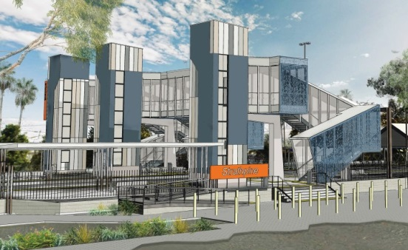
Strathpine station accessibility upgrade

PROJECT UPDATE – OCTOBER 2018

The Strathpine station accessibility upgrade is part of Queensland Rail’s $300 million program to upgrade stations across the South East Queensland network, making them accessible for all customers.

Project progress
The following works were recently undertaken:
- opening of the temporary footbridge
- opening of the temporary platform and closure of the South Pine Road end of platform 2/3
- removal of the original footbridge.

The ramp to platform 2/3 (at South Pine Road level crossing) is now closed for construction. Please see station staff if you require assistance accessing the station or boarding services.
Upcoming works
This month, customers and the community can expect to see the following construction activities:
- minor demolition works
- electrical/communications service identification, relocation or removal to enable construction
- preparatory activities prior to the commencement of main construction works.
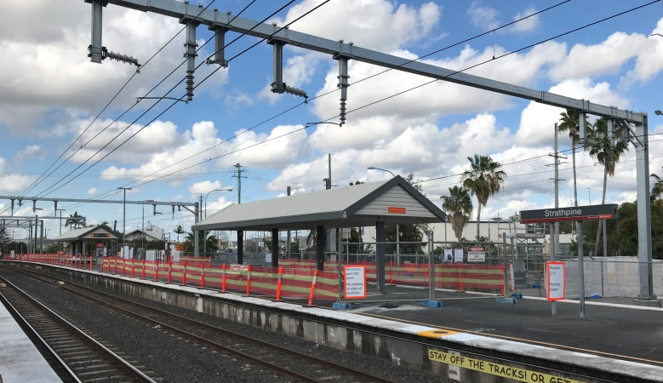

Platform 2/3 closed for construction

Delivery of Queensland Rail’s $300 million Station Accessibility Upgrade Program will mean about 83% of customers will travel to or from an accessible station.

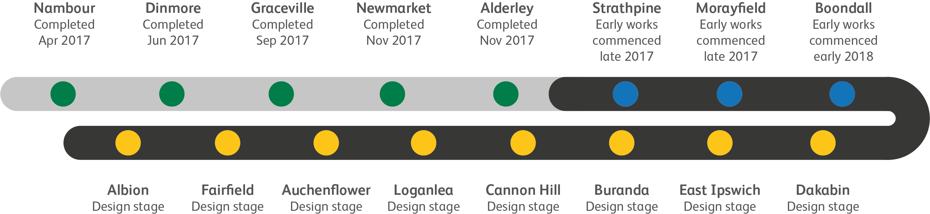
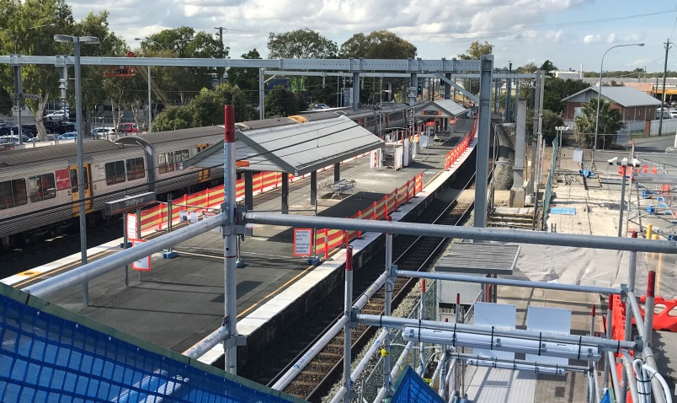
Original footbridge makes way for construction of lifts

Construction impacts

Normal working hours are 6am to 5pm Monday to Saturday. Construction activities may involve:

noise associated with heavy machinery

temporary changes to access paths throughout the station precinct

changed traffic and parking conditions

increased vehicle movements near works

mobile lighting towers for night works.

Please follow all directional signage and take care around the work zones.

We thank customers and the community for their patience and cooperation during this important project.

Contact us

For more information or to provide feedback:

Phone: 1800 722 203 (free call)

Email: stationsupgrade@qr.com.au

Website: queenslandrail.com.au

