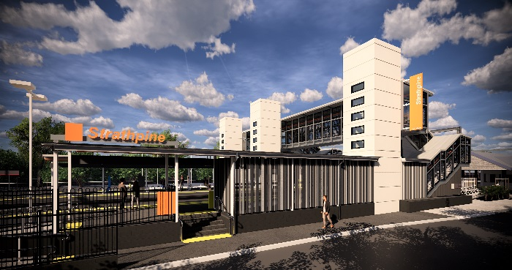
Strathpine station accessibility upgrade

PROJECT UPDATE – OCTOBER 2019

The Strathpine station accessibility upgrade is part of the State Government’s $357 million program to upgrade stations across the South East Queensland network, making them accessible for all customers.

Project progress
During September, the following activities were undertaken:
- concreting raised section – platform 2/3
- commenced shelter installation – platform 2/3
- stormwater drainage works – platform 2/3
- electrical and communications installations – platform 1.

Upcoming works
In the coming weeks, customers and the community can expect to see the following activities:
- commencement of bicycle enclosure works
- paving – platform 2/3
- shelter works – platform 2/3
- lighting installations – platform 2/3
- ongoing lift car installations.

Please follow all directional signage and take care around the work zones.
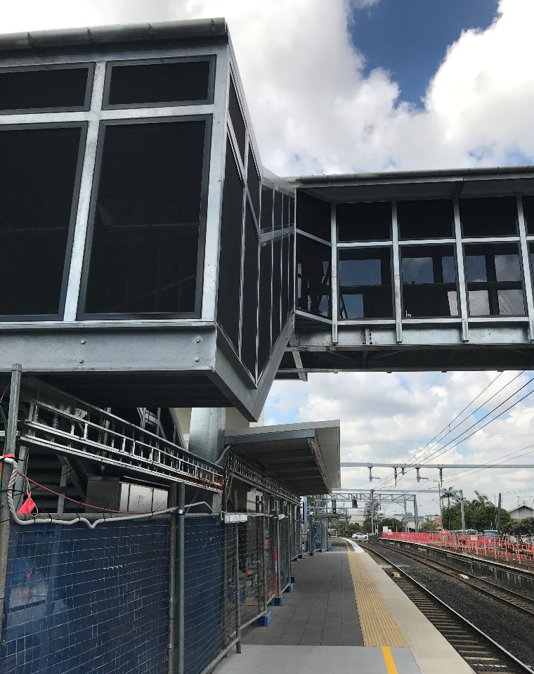

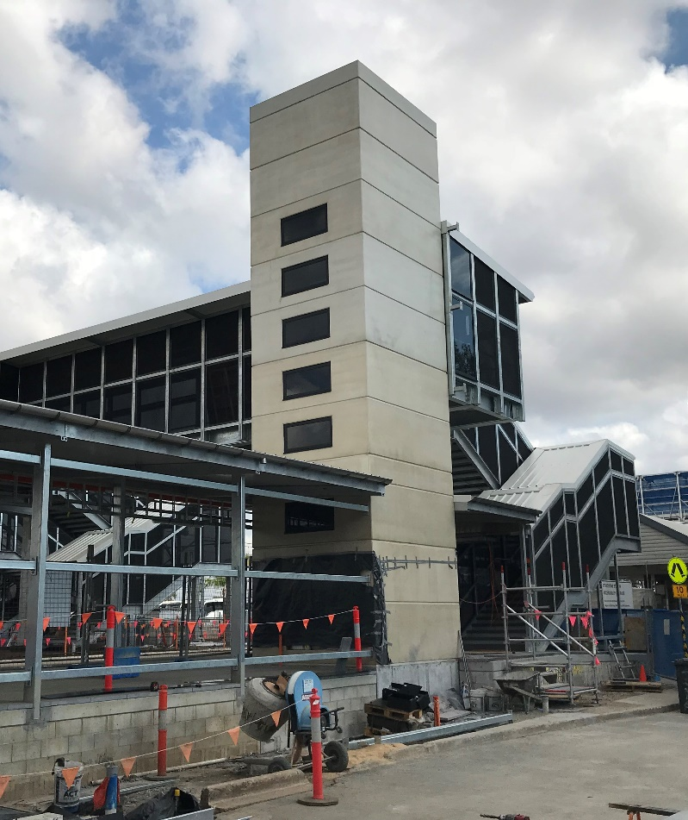

Station entrance works – eastern carpark

Construction impacts

Normal working hours are 6am to 5pm, Monday to Saturday. Construction activities may involve:

noise associated with heavy machinery

temporary changes to access paths throughout the station precinct

ramp access to platform 2/3 (at level crossing) closed

changed traffic and parking conditions

increased vehicle movements near works

mobile lighting towers for night works.

Thank you for your patience and cooperation as we work to improve your station.

Contact us

For more information or to provide feedback:

Phone: 1800 722 203 (free call)

Email: stationsupgrade@qr.com.au

Website: queenslandrail.com.au

Platform 1 – raised section

