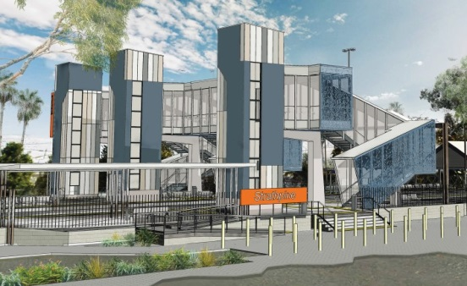
Strathpine station accessibility upgrade

PROJECT UPDATE – SEPTEMBER 2018

The Strathpine station accessibility upgrade is part of Queensland Rail’s $300 million program to upgrade stations across the South East Queensland network, making them accessible for all customers.

Project progress
The following works were recently undertaken:
- contractor site establishment
- project compound and safety fencing
- changes to some parking to enable works
- completion of temporary platform
- installation of temporary footbridge.

Upcoming works
This month, customers and the community can expect to see the following construction activities:
- opening of the temporary footbridge
- commissioning of the temporary platform
- removal of original footbridge.

The ramp to platform 2/3 (at South Pine Road level crossing) will be closed for construction from Monday 17 September. Please see station staff if you require assistance accessing the station or boarding services.
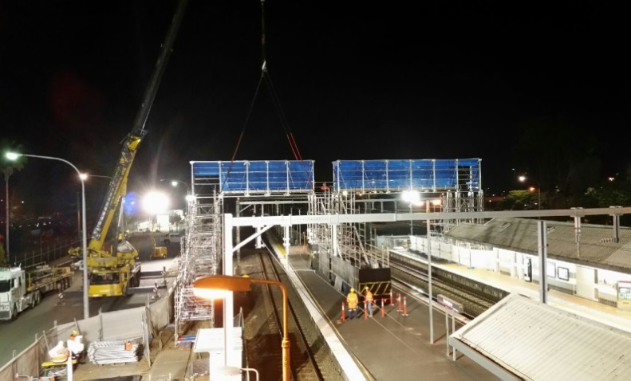
Installation of temporary footbridge, late August

Delivery of Queensland Rail’s $300 million Station Accessibility Upgrade Program will mean about 83% of customers will travel to or from an accessible station.

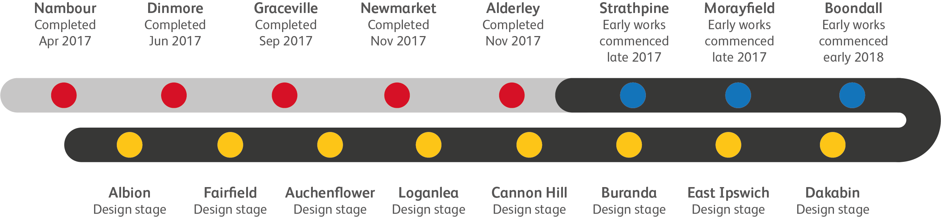
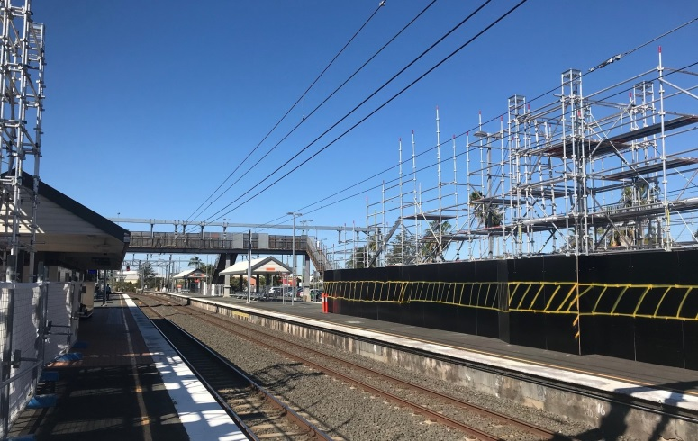
Temporary footbridge staircase construction

Construction impacts

Normal working hours are 6am to 5pm Monday to Saturday. Construction activities may involve:

noise associated with heavy machinery

temporary changes to access paths throughout the station precinct

changed traffic and parking conditions

increased vehicle movements near works

mobile lighting towers for night works.

Please follow all directional signage and take care around the work zones.

Queensland Rail thanks customers and the community for their patience and cooperation during this important project.

Contact us

For more information or to provide feedback:

Phone: 1800 722 203 (free call)

Email: stationsupgrade@qr.com.au

Website: queenslandrail.com.au

