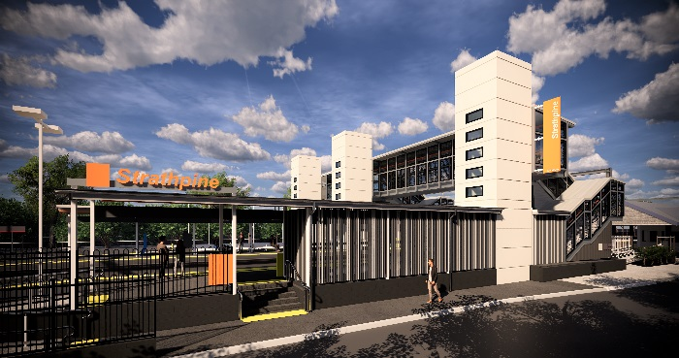
Strathpine station accessibility upgrade

PROJECT UPDATE – SEPTEMBER 2019

Queensland Rail’s Strathpine station accessibility upgrade is part of the program to upgrade stations across the South East Queensland network, making them accessible for all customers.

Project progress
Last month, the following activities were undertaken:
- surface works – platform 1
- lift shaft installation – platform 2/3 (pictured, right)
- ongoing lift car installation – platform 1
- ongoing construction of new accessible entrance – platform 1
- footbridge fit-out works.

Upcoming works
In the coming weeks, customers and the community can expect to see the following activities:
- ongoing lift car installations
- concreting platform 2/3
- stormwater drainage works – platform 2/3
- carpark and footpath lighting works.

Please follow all directional signage and take care around the work zones.

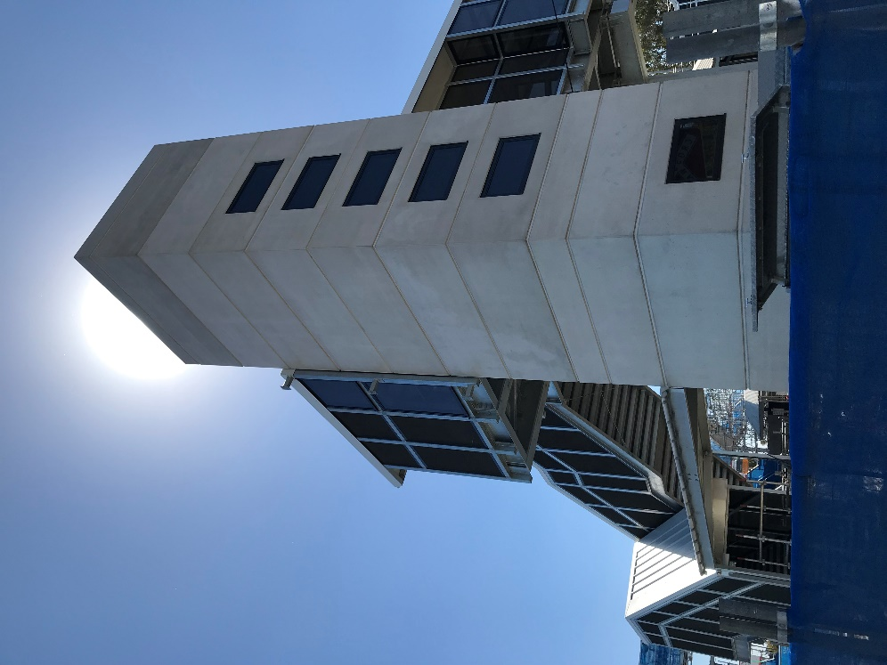

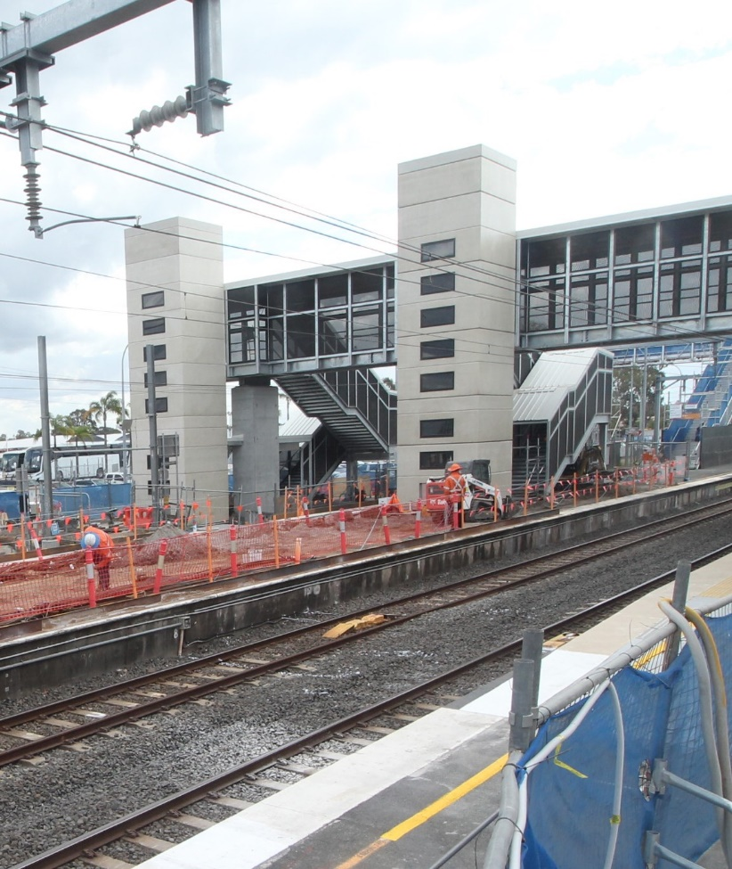

Construction impacts

Normal working hours are 6am to 5pm, Monday to Saturday. Construction activities may involve:

noise associated with heavy machinery

temporary changes to access paths throughout the station precinct

ramp access to platform 2/3 (at level crossing) closed

changed traffic and parking conditions

increased vehicle movements near works

mobile lighting towers for night works.

Thank you for your patience and cooperation as we work to improve your station.

Contact us

For more information or to provide feedback:

Phone: 1800 722 203 (free call)

Email: stationsupgrade@qr.com.au

Website: queenslandrail.com.au

