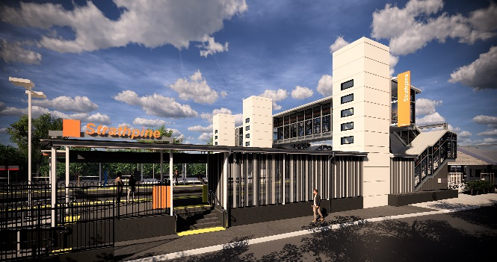
Strathpine station accessibility upgrade

WORKS NOTICE

After hours works
January/February 2020
As part of the Strathpine station accessibility upgrade, Queensland Rail will demolish and remove the station’s temporary platform over four nights from Monday 27 to Thursday 30 January, each night from 5pm until 6am the next day (weather and construction conditions permitting).
Upgrade works will then continue throughout the station precinct from 2am Saturday 1 to 4am Monday 3 February, during the scheduled weekend track closure.
For the safety of customers and project workers, these works must be carried out at times when there is no rail traffic and fewer customers around the station precinct.
While the northern end of the western carpark will be closed to vehicles, pedestrian access will be maintained.
The station footbridge will be closed for flooring works from 9am to 3pm on Saturday 1 February.
Residents near the station may experience some noise associated with upgrade activities and truck movements. Mobile lighting towers will be used during night works.
Every effort will be made to minimise disruption and we apologise for any inconvenience as we work to improve your station.

Overview of works
Queensland Rail Limited ABN 71 132 181 090
Location | Dates and hours of work | Type of work
Strathpine station  Western carpark – partial closure 4pm Monday 27 January to 6am Monday 3 February (pedestrian access maintained)  Footbridge – closed Saturday 1 February, 9am to 3pm | Night works (platform removal):  Monday 27 to Thursday 30 January, 5pm to 6am the next day  (over 4 nights)  and  During scheduled track closure:  2am Saturday 1 to 4am Monday 3 February  (continuous works) | Station upgrade works involving:  - removal of the temporary platform  - operation of heavy machinery and trucks with flashing lights and reversing beepers  - use of hand-held tools and powered equipment  - movement of personnel and vehicles around the station precinct  - portable lighting towers at night.
The Strathpine station accessibility upgrade is part of the State Government’s $357 million investment to upgrade stations across the South East Queensland network, making them accessible for all customers.
For more information about the accessibility upgrade, please contact the project’s community team during business hours on 1800 722 203 (free call) or email stationsupgrade@qr.com.au

We are moving towards paperless notifications about noise and works. You will still see paper notices as we transition to the new system. Sign up at queenslandrail.com.au/EmailNotification or contact us if you prefer to receive paper copies.

