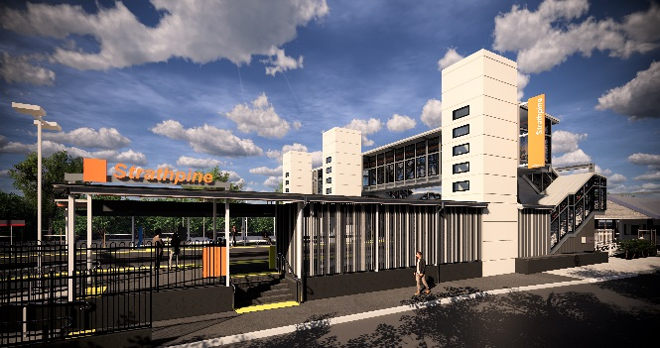
Strathpine station accessibility upgrade

WORKS NOTICE

Night works – temporary platform removal
March 2020
As part of the Strathpine station accessibility upgrade, Queensland Rail will continue the demolition and removal of the station’s temporary platform over five nights from Monday 2 to Friday 6 March, each night from 5pm until 6am the next day (weather and construction conditions permitting).
For the safety of customers and project workers, these works must be carried out at times when there is no rail traffic and fewer customers around the station precinct.
While the western carpark will be partially closed during these works, pedestrian access will be maintained between Nicol Way and South Pine Road and the station footbridge.
Residents near the station may experience some noise associated with upgrade activities and truck movements. Mobile lighting towers will be used during night works.
Every effort will be made to minimise disruption and we apologise for any inconvenience as we work to improve your station.

Overview of works
Queensland Rail Limited ABN 71 132 181 090
Location | Dates and hours of work | Type of work
Strathpine station  Western carpark – partial closure 4pm Sunday 1 to 12noon Saturday 7 March (pedestrian access maintained) | Monday 2 to Friday 6 March, 5pm to 6am the next day  (over 5 nights) | Station upgrade works involving:  - removal of the temporary platform  - operation of heavy machinery and trucks with flashing lights and reversing beepers  - use of hand-held tools and powered equipment  - movement of personnel and vehicles around the station precinct  - portable lighting towers at night.
Platform removal works will continue during night works and a weekend track closure scheduled in early April (to be notified on a separate notification closer to the works).
The Strathpine station accessibility upgrade is part of the State Government’s $357 million investment to upgrade stations across the South East Queensland network, making them accessible for all customers.
For more information about the accessibility upgrade, please contact the project’s community team during business hours on 1800 722 203 (free call) or email stationsupgrade@qr.com.au

We are moving towards paperless notifications about noise and works. You will still see paper notices as we transition to the new system. Sign up at queenslandrail.com.au/EmailNotification or contact us if you prefer to receive paper copies.

