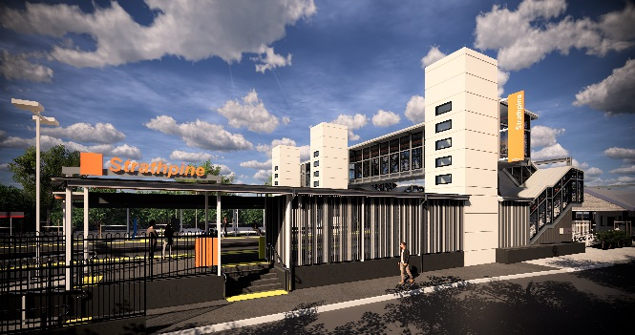
Strathpine station accessibility upgrade

WORKS NOTICE

After hours works – footbridge
- Deliveries: from 2am Tuesday 21 May 2019
- Installation: Saturday 1 and Sunday 2 June 2019
As part of the Strathpine station accessibility upgrade, night and weekend works will be undertaken during late May/early June 2019.
Deliveries of bridge sections to the western carpark have been scheduled from 2am on Tuesday 21 May. Installation of the station’s new footbridge will be carried out during a scheduled weekend track closure, from 11pm Friday 31 May to 4am Monday 3 June. For safety reasons, these works can only be undertaken when there is no rail traffic and the overhead power is switched off.
To enable the assembly and installation of the new footbridge, the western carpark will be temporarily unavailable from 4am Saturday 18 May to 4am Tuesday 4 June 2019.
Pedestrian access through the carpark to the temporary stair-only footbridge and South Pine Road level crossing will be maintained. For public safety, there may be short temporary access restrictions for pedestrians. Please follow directional signage and take care around the work zones.
Residents near the station may experience some noise associated with construction activity and truck movements. Mobile lighting towers will be used, as required, during night works. Every effort will be made to minimise disruption and we apologise for any inconvenience as we work to improve your station.

Scheduled work
Location | Dates and hours of work | Type of work
Strathpine station  Western carpark | Deliveries of bridge sections:  - Tuesday 21 May, from 2am (early morning works)  Bridge installation:  - 11pm Friday 31 May to 4am Monday 3 June (continuous works during scheduled track closure) | Delivery and on-site assembly of footbridge sections involving:  - large cranes, heavy machinery and trucks with flashing lights and reversing beepers  Queensland Rail Limited ABN 71 132 181 090  - hand-held tools and powered equipment  - movement of personnel and vehicles around the station precinct  - portable lighting towers at night.
 | Western carpark closed:  - 4am Saturday 18 May to 4am Tuesday 4 June | Western carpark closed for works:  - temporary (stair-only) footbridge open for cross-corridor access  - pedestrian access through western carpark open (with short delays for safety).
The Strathpine station accessibility upgrade is part of Queensland Rail’s $300 million program to upgrade stations across the South East Queensland network, making them accessible for all customers. For more information, contact the project team on 1800 722 203 (free call) or email stationsupgrade@qr.com.au

We are moving towards paperless notifications about noise and works. You will still see paper notices as we transition to the new system. Sign up at queenslandrail.com.au/EmailNotification or contact us if you prefer to receive paper copies.

