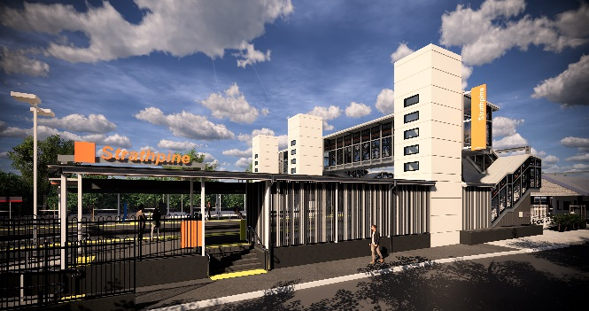
Strathpine station accessibility upgrade

WORKS NOTICE

Weekend/night works – platform surfacing and concrete demolition
11am Saturday 14 to 11pm Sunday 15 December 2019

As part of the Strathpine station accessibility upgrade, Queensland Rail will undertake platform surfacing, signalling and concrete ramp demolition works between 11am Saturday 14 and 11pm Sunday 15 December 2019 (weather and construction conditions permitting).
For the safety of customers and project workers, these works must be carried out outside of peak services or at times when there is reduced rail traffic and fewer customers around the station precinct.
During these works, the station will continue to operate and rail services will not be affected.
Residents near the station may experience some noise associated with construction activity and truck movements. Mobile lighting towers will be used, as required, during night works. Every effort will be made to minimise disruption and we apologise for any inconvenience as we work to improve your station.

Scheduled weekend/night work
Queensland Rail Limited ABN 71 132 181 090
Location | Dates and hours of work | Type of work
Strathpine station:  - platform 2/3 | 11am Saturday 14 to 11pm Sunday 15 December  (continuous works) | Station upgrade works involving:  - platform surfacing works including asphalting  - demolition of concrete ramp using rock-breaking equipment eg. jackhammers  - signalling installation and cabling  - machinery and trucks with flashing lights and reversing beepers  - hand-held tools and powered equipment  - movement of personnel and vehicles around the station precinct  - portable lighting towers at night.
The Strathpine station accessibility upgrade is part of the State Government’s $357 million investment to upgrade stations across the South East Queensland network, making them accessible for all customers.
For more information about the accessibility upgrade, please contact the project’s community team during business hours on 1800 722 203 (free call) or email stationsupgrade@qr.com.au

We are moving towards paperless notifications about noise and works. You will still see paper notices as we transition to the new system. Sign up at queenslandrail.com.au/EmailNotification or contact us if you prefer to receive paper copies.

