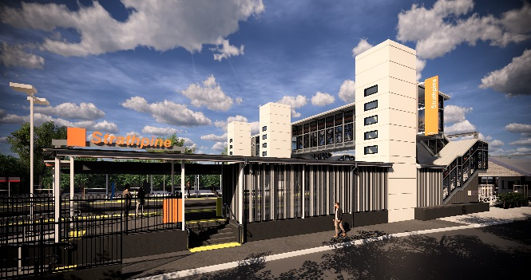
Strathpine station accessibility upgrade

WORKS NOTICE

Night and weekend works – temporary footbridge removal
6pm Saturday 2 to 4pm Sunday 3 November 2019

As part of the Strathpine station accessibility upgrade, night and weekend works will be undertaken from 6pm Saturday 2 to 4pm Sunday 3 November 2019.
These works can only be undertaken at night when there is no rail traffic and the overhead power is switched off.
The western carpark and a small section of the eastern carpark will be closed during these weekend works. Cross-corridor pedestrian access will be maintained through the carpark to the station’s new footbridge (stair-only access) and South Pine Road level crossing. Please follow directional signage and take care around the work zones.
Residents near the station may experience some noise associated with construction activity and truck movements. Mobile lighting towers will be used, as required, during night works.

Scheduled night/weekend work
Queensland Rail Limited ABN 71 132 181 090
Location | Dates and hours of work | Type of work
Strathpine station  Western carpark closed  (pedestrian access only)  Eastern carpark (small section closed, near station building)  New footbridge (open – stair-only access) | 6pm Saturday 2 to 4pm Sunday 3 November  (overnight and Sunday works)  Western carpark closed 5am Friday 1 to 5pm Monday 4 November  Eastern carpark (section near station building) closed 6pm Friday 1 to 7am Sunday 3 November | Removal of the temporary footbridge involving:  - large crane operation  - heavy machinery and trucks with flashing lights and reversing beepers  - hand-held tools and powered equipment  - movement of personnel and vehicles around the station precinct  - portable lighting towers at night.
Every effort will be made to minimise disruption and we apologise for any inconvenience as we work to improve your station.
The Strathpine station accessibility upgrade is part of the State Government’s $357 million program to upgrade stations across the South East Queensland network, making them accessible for all customers.
For more information about the accessibility upgrade, please contact the project’s community team on free call 1800 722 203 or email stationsupgrade@qr.com.au

We are moving towards paperless notifications about noise and works. You will still see paper notices as we transition to the new system. Sign up at queenslandrail.com.au/EmailNotification or contact us if you prefer to receive paper copies.

