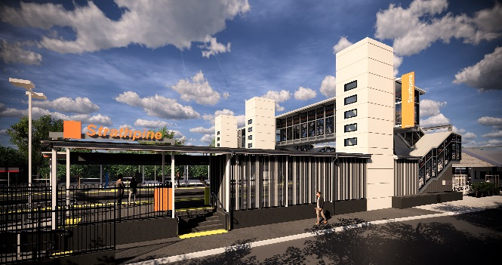
Strathpine station accessibility upgrade

WORKS NOTICE

Night works – platforms
October 2019

As part of the Strathpine station accessibility upgrade, overnight works will be undertaken at the station from 11pm on Friday 11 October 2019 until 6am the next day (weather and construction conditions permitting). This is a continuation of the night works previously notified.
For the safety of customers and project workers, these works must be carried out outside of peak services or at night when there is no rail traffic.
Residents near the station may experience some noise associated with construction activity and truck movements. Mobile lighting towers will be used, as required, during night works.

Scheduled night/weekend work
Queensland Rail Limited ABN 71 132 181 090
Location | Dates and hours of work | Type of work
Strathpine station:  - platform 2/3 | 11pm to 6am the next day on:  - Friday 11 October  (overnight) | Station upgrade works involving:  - transfer of building materials and machinery to island platform 2/3 in preparation for future works  - platform surfacing works  - heavy machinery and trucks with flashing lights and reversing beepers  - hand-held tools and powered equipment  - movement of personnel and vehicles around the station precinct  - portable lighting towers at night.

The temporary footbridge will be open as usual for cross-corridor pedestrian access.
Every effort will be made to minimise disruption and we apologise for any inconvenience as we work to improve your station.
The Strathpine station accessibility upgrade is part of Queensland Rail’s program to upgrade stations across the South East Queensland network, making them accessible for all customers.
For more information about the accessibility upgrade, please contact the project’s community team during business hours on 1800 722 203 (free call) or email stationsupgrade@qr.com.au

We are moving towards paperless notifications about noise and works. You will still see paper notices as we transition to the new system. Sign up at queenslandrail.com.au/EmailNotification or contact us if you prefer to receive paper copies.

