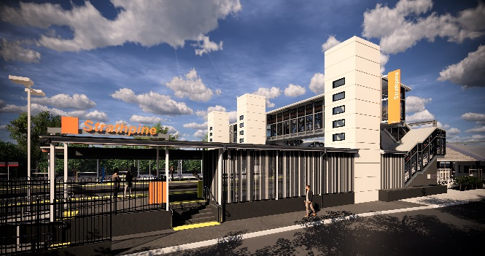
Strathpine station accessibility upgrade

WORKS NOTICE

Night works – platform works
Sunday 19 January 2020

In preparation for the reopening of the upgraded platform 2/3, as part of the Strathpine station accessibility upgrade, preparation works will be undertaken at night from 11pm Sunday 19 January until 6am the next day (weather and construction conditions permitting).
Works are not expected to create excessive noise and will include painting and the removal/relocation of safety fencing.
For the safety of customers and project workers, these works can only be carried out when there is no rail traffic.
Residents near the station may experience some noise associated with platform activities and truck movements. Mobile lighting towers will be used, as required, during night works.

Scheduled night/weekend work
Queensland Rail Limited ABN 71 132 181 090
Location | Dates and hours of work | Type of work
Strathpine station:  - platform 2/3 | 11pm to 6am the next day on:  - Sunday 19 January  (overnight) | Station upgrade works involving:  - platform preparation works including painting  - removal or relocation of temporary fencing  - hand-held tools and powered equipment  - movement of personnel and vehicles (with flashing lights and reversing beepers) around the station precinct  - portable lighting towers at night.
The station footbridge will be open as usual for cross-corridor pedestrian access.
Every effort will be made to minimise disruption and we apologise for any inconvenience as we work to improve your station.
The Strathpine station accessibility upgrade is part of the State Government’s $357 million investment to upgrade stations across the South East Queensland network, making them accessible for all customers.
For more information about the accessibility upgrade, please contact the project’s community team during business hours on 1800 722 203 (free call) or email stationsupgrade@qr.com.au

We are moving towards paperless notifications about noise and works. You will still see paper notices as we transition to the new system. Sign up at queenslandrail.com.au/EmailNotification or contact us if you prefer to receive paper copies.

