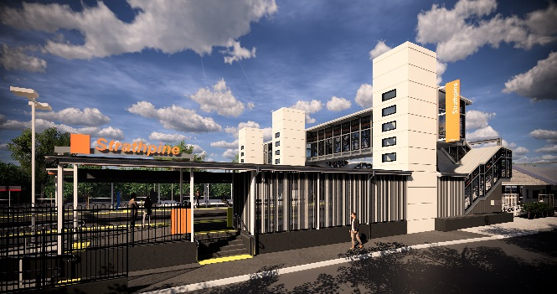
Strathpine station accessibility upgrade

WORKS NOTICE

Night works – platforms
September/October 2019

As part of the Strathpine station accessibility upgrade, night works will be undertaken at the station on selected nights in late September and early October 2019.
For the safety of customers and project workers, these works must be carried out outside of peak services or at night when there is no rail traffic.
Residents near the station may experience some noise associated with construction activity and truck movements. Mobile lighting towers will be used, as required, during night works.

Scheduled night/weekend work
Queensland Rail Limited ABN 71 132 181 090
Location | Dates and hours of work | Type of work
Strathpine station:  - Western carpark and project compound (delivery of crane and materials)  - Platform 2/3 (asphalt works) | 11pm to 6am the next day on:  - Monday 30 September  (delivery of crane and materials)  - Wednesday 9 and Thursday 10 October  (over 2 nights – platform asphalt works) | Station upgrade works involving:  - delivery of crane and construction materials to site by truck  - asphalt works on station platform  - heavy machinery and trucks with flashing lights and reversing beepers  - hand-held tools and powered equipment  - movement of personnel and vehicles around the station precinct  - portable lighting towers at night.

The footbridge will be open as usual for cross-corridor pedestrian access.
Every effort will be made to minimise disruption and we apologise for any inconvenience as we work to improve your station.
The Strathpine station accessibility upgrade is part of Queensland Rail’s program to upgrade stations across the South East Queensland network, making them accessible for all customers.
For more information about the accessibility upgrade, please contact the project’s community team during business hours on 1800 722 203 (free call) or email stationsupgrade@qr.com.au

We are moving towards paperless notifications about noise and works. You will still see paper notices as we transition to the new system. Sign up at queenslandrail.com.au/EmailNotification or contact us if you prefer to receive paper copies.

