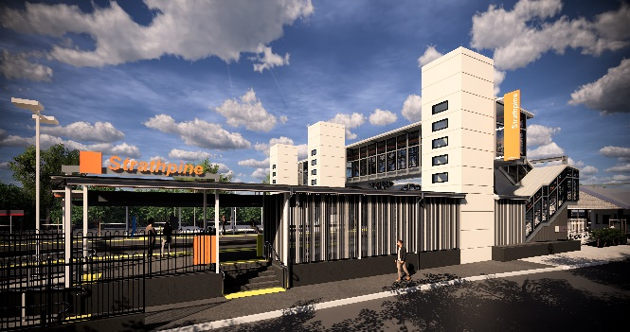
Strathpine station accessibility upgrade

WORKS NOTICE

Night works – electrical works
Tuesday 11 February 2020

As part of the Strathpine station accessibility upgrade, electrical works will be undertaken overnight on Tuesday 11 February from 10pm to 6am the next day (weather and construction conditions permitting).
Residents near the station may experience some noise associated with personnel and vehicles around the station precinct.
Activities include the use of generators. Mobile lighting towers will be used, as required, during night works.
Queensland Rail Limited ABN 71 132 181 090

Scheduled night work
Location | Dates and hours of work | Type of work
Strathpine station | 10pm to 6am the next day on:  - Tuesday 11 February  (overnight) | Electrical works involving:  - operation of generators  - hand-held tools and powered equipment  - movement of personnel and vehicles (with flashing lights and reversing beepers) around the station precinct  - portable lighting towers at night.

The station footbridge will be open as usual for cross-corridor pedestrian access.
Every effort will be made to minimise disruption and we apologise for any inconvenience as we work to improve your station.
The Strathpine station accessibility upgrade is part of the State Government’s $357 million investment to upgrade stations across the South East Queensland network, making them accessible for all customers.
For more information about the accessibility upgrade, please contact the project’s community team during business hours on 1800 722 203 (free call) or email stationsupgrade@qr.com.au

We are moving towards paperless notifications about noise and works. You will still see paper notices as we transition to the new system. Sign up at queenslandrail.com.au/EmailNotification or contact us if you prefer to receive paper copies.

