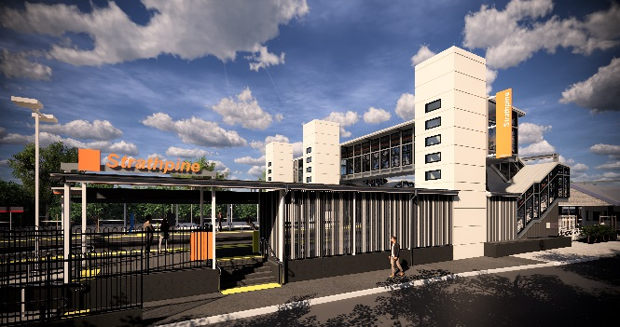
Strathpine station accessibility upgrade

WORKS NOTICE

Weekend works – carpark surfacing
Saturday 22 and Sunday 23 February 2020

As part of the Strathpine station accessibility upgrade, Queensland Rail will undertake asphalting works on Saturday 22 and Sunday 23 February, 6am to 6pm each day (weather and construction conditions permitting).
To enable these works, the western carpark will be closed to customer vehicles from 5am Friday 21 until 6pm Sunday 23 February. Pedestrian access will be maintained at all times between Nicol Way and South Pine Road. The station footbridge and lifts will remain open for customer and pedestrian access.
Residents near the station may experience some noise associated with construction activities, truck movements and the operation of jackhammers and an asphalting machine.

Scheduled weekend work
Queensland Rail Limited ABN 71 132 181 090
Location | Dates and hours of work | Type of work
Strathpine station and western carpark | 6am to 6pm (day works) on:  - Saturday 22 February  - Sunday 23 February | Station upgrade works involving:  - surfacing works in the western carpark, including the operation of an asphalting machine  - use of jackhammers and compacting machinery  - operation of heavy equipment and trucks with flashing lights and reversing beepers  - use of hand-held tools and powered equipment  - movement of personnel around the station precinct.

Every effort will be made to minimise disruption and we apologise for any inconvenience as we work to improve your station.
The Strathpine station accessibility upgrade is part of the State Government’s $357 million investment to upgrade stations across the South East Queensland network, making them accessible for all customers.
For more information about the accessibility upgrade, please contact the project’s community team during business hours on 1800 722 203 (free call) or email stationsupgrade@qr.com.au

We are moving towards paperless notifications about noise and works. You will still see paper notices as we transition to the new system. Sign up at queenslandrail.com.au/EmailNotification or contact us if you prefer to receive paper copies.

